A Web Portal for the History of Medicine
Jean-François VINCENT
Bibliothèque interuniversitaire de médecine et d'odontologie, Paris, France
(jean-francois.vincent@univ-paris5.fr)
Overview
BIUM'S collection is one of the three largest historical collections of medicine in the world. We want to promote it and build a place on the Internet for the history of medicine. It is not a small ambition. We have already build a bit of it, that this paper will describe.
Since 2001, under the impulse of Guy Cobolet, head of the BIUM, an Internet portal is being developed by the history of medicine service (URL: http://www.bium.univ-paris5.fr/histmed).
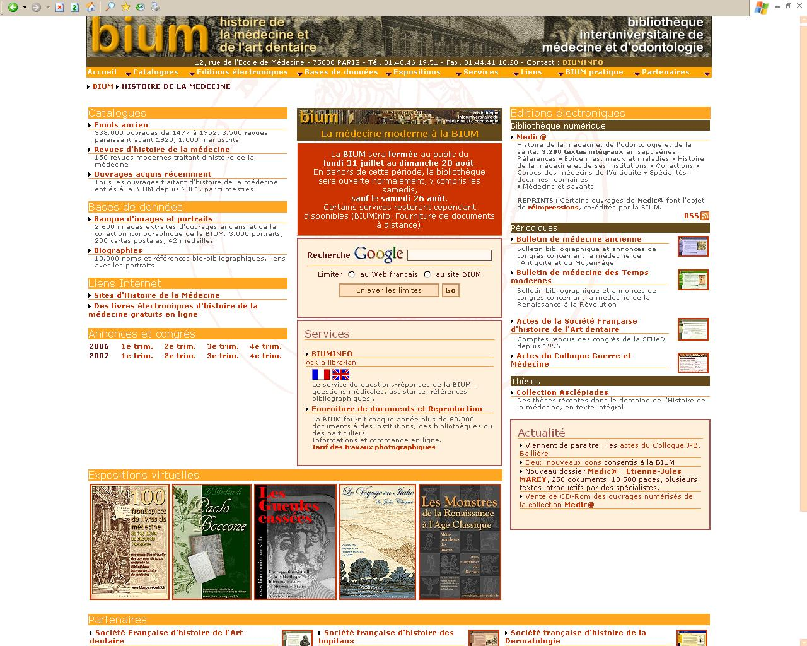
Fig. 1: History of medicine Home Page
Its aim is to serve the communities interested by this domain. Interested communities are rather diverse:
- historians of medicine or doctors interested in the history of medicine
- historians of sciences
- researchers in social history
- historians of art
- philosophers
- philologists
- iconographers
- book-lovers, etc.
Our library's mission is to serve mainly a public of research level. In accordance with it, the Web portal is mainly (but not only) targeted to academics. Multidisciplinary approach is promoted whenever possible: this is in conformity with the spirit of the time, but also with our collections. From its beginnings (in the middle of the XVIIIth Century) until a recent date, the library of the Faculté de médecine de Paris was not seen as a specialized library as we understand it now. Thus, if a large part of the medical knowledge of the past can be found on our shelves, it is side by side with interesting collections of zoology, botany, anthropology, philosophy, and in general all the books that were thought to be useful for medical studies.
A number of Web services have been set up to BIUM’s privileged patrons, all of them freely available on the Internet. Some of them are targeted to very definite communities, some others for broader ones. The general public is not forgotten.
This paper reviews these Web services. It ends with an overview of collaborative works, either achieved or on the way.
Web services for specific communities
They are in fact stand-alone Web sites, almost separated from the main BIUM site.
Ancient Medicine Newsletter and Early Medicine Newsletter
Two of those sites are bulletins, and are entirely written by BIUM staff. Those twin sites are for researchers in ancient medicine and in early modern medicine. You can find there:
- targeted announcements (congress, grants, books subscriptions...)
- current bibliographies
- original documents which, for various reasons, have not been published on paper (e. g. Esculape database, a collection of Latin terms of pathology)
- researchers directory
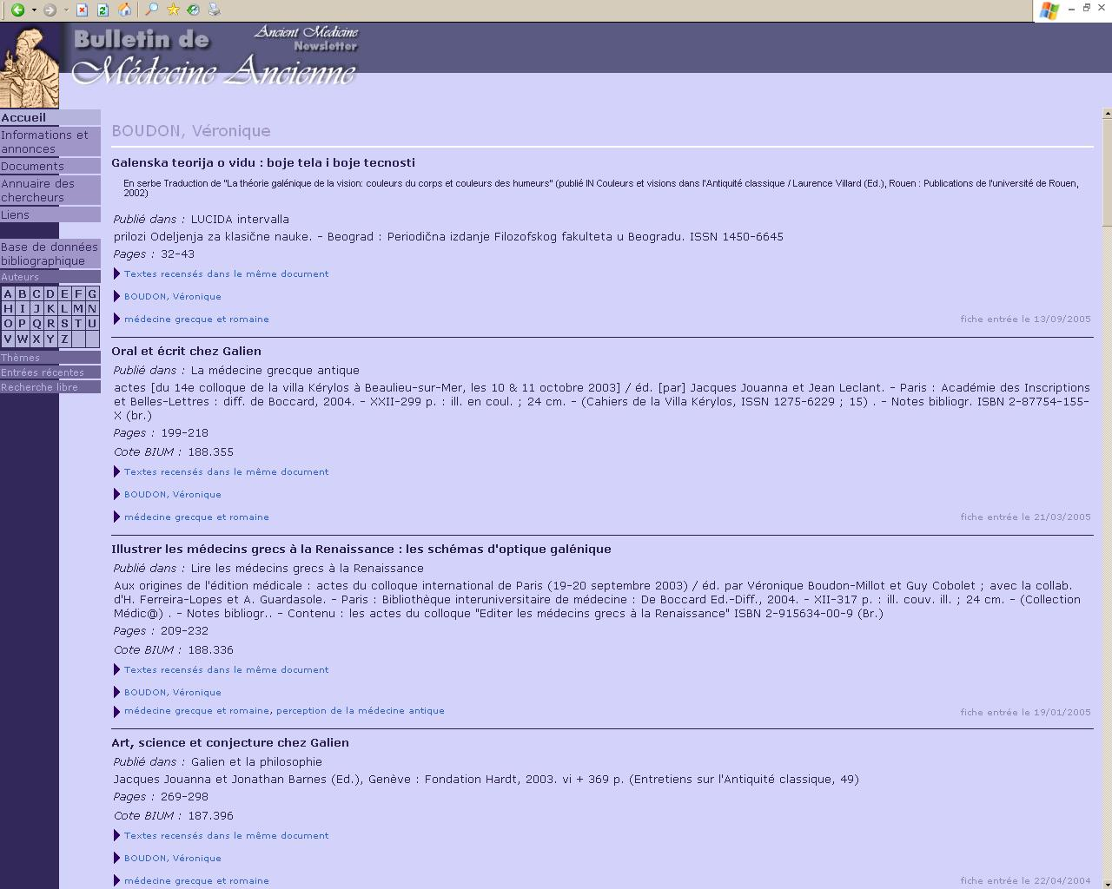
Fig. 2: Ancient Medicine Newsletter, bibliographies
URLs: http://www.bium.univ-paris5.fr/amn/ , http://www.bium.univ-paris5.fr/bmtm
Web Site Hosting
Our Web server offers Web hosting and technical support to ten learned societies:
- Académie nationale de Chirurgie
- Association de sauvegarde du Patrimoine de l'Art dentaire
- Musée d'Histoire de la Médecine, Paris
- Société Botanique de France
- Société d'Histoire et d'Epistémologie des Sciences de la Vie
- Société française d'histoire de la Dermatologie
- Société Française d'histoire de la Médecine
- Société Française d'histoire de l'Art dentaire
- Société française d'histoire des hôpitaux
- Société Française pour l'Histoire des Sciences de l'Homme
- Société Internationale d'Histoire de la Médecine (in French, English and Spanish)
Three on-line periodicals are also put on line:
- Actes de la société française d’histoire de l’art dentaire
- e-Mémoires de l'Académie Nationale de Chirurgie
- Actes du Colloque Guerre et médecine
BIUM considers itself as a technical service provider for associations or institutions needing a Web infrastructure. We offer them our technical knowledge, and time work for Web design and layout.
Web services for broader communities
Ask a librarian and document delivery
In front of you, it will be enough to mention two important and efficient services that we offer. The first one is called BIUM-Info, and is an “Ask a librarian” service. The other one is a traditional and quick document delivery service.
URLs: http://www.bium.univ-paris5.fr/medecine/refvirt_cad.htm (BIUM-Info), http://www.bium.univ-paris5.fr/medecine/peb_ang.htm (Document supply)
Images and portraits database
Our images and portraits database is mainly the result of the digitization of BIUM's picture collection. It contains 8500 pictures. We intend to enhance and enlarge it in the near future. The technical improvement that we think as a priority is to make it visible to the general search engines, and to be able to export our metadata with OAI-PMH protocol.
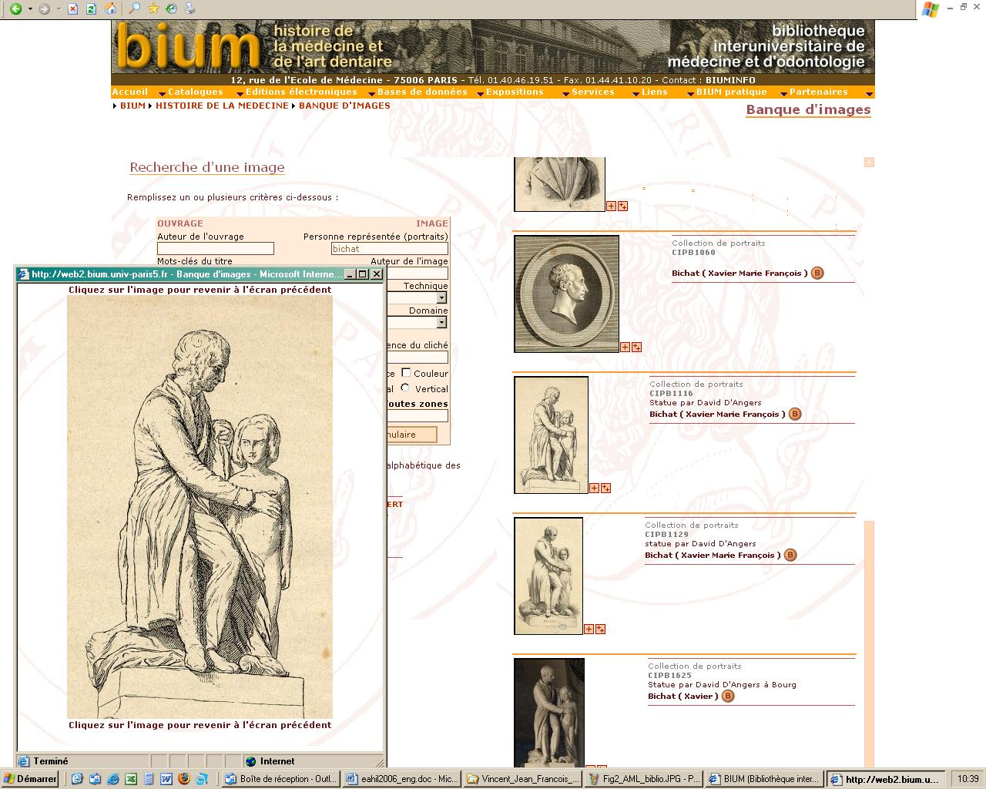
Fig. 3: Images and portraits Database
URL: http://www.bium.univ-paris5.fr/histmed/hm_img.htm
Bio-bibliographical database
13700 records with biographical references of medical people, scientists, famous people about whom bio-pathologic literature exists.
URL: http://www.bium.univ-paris5.fr/histmed/hm_bio.htm
Medic@ digital library
Medic@ is probably the main part of the site, and it is definitely the service in which we put more efforts in. You can find in it 3400 full text documents (680000 pages). We think we shall pass the million pages before the mid-2007.
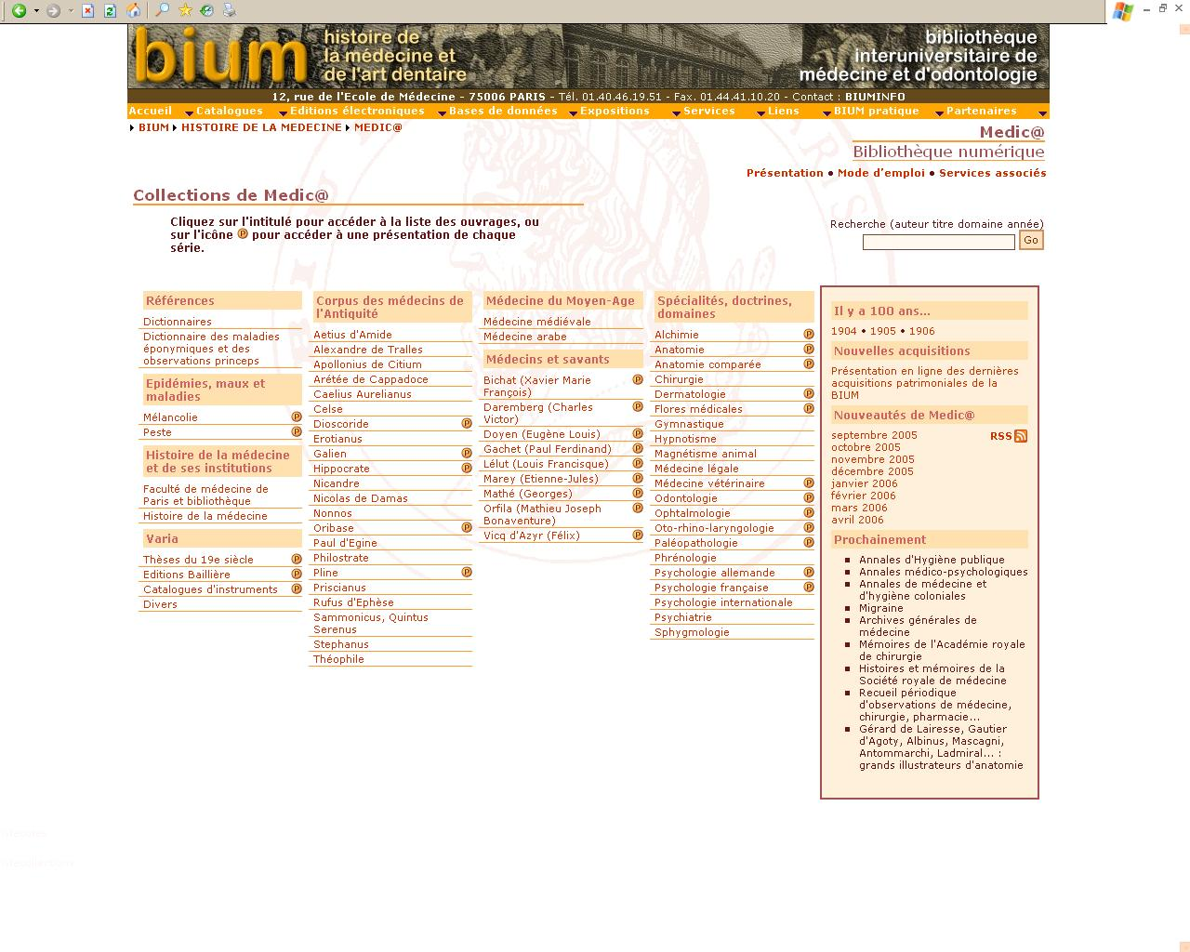
Fig. 4: Medic@’s Home Page
In a nutshell, here is our digitization policy:
- goals: promote the BIUM's rich and rare collections, as well as its other information services
- targets: researchers interested in the history of medicine, dentistry and health
- content: medicine, dentistry, health. Medic@ wishes to promote multidisciplinary topics (e. g. Ancient physicians' corpus: history of medicine, philology, ancient history; Etienne-Jules Marey: cardiology, physiology, cinema, photography...)
- Digitized documents:
  - documents in the public domain,
  - belonging to the BIUM
  - organized in series (e. g. Medical Specialties, Physicians and Scholars) subdivided in files (dermatology, Bichat...)
  - files are accompanied by one or more original papers written by specialists. From this year, the papers are in French and in English.
- Technical aspects
  - image mode, but easily browsable with navigation tools (most often, the digitized table of contents and the legends of the illustrations.)
  - some very important documents, that we consider as research tools, may be searched through specific search engines (dictionaries, and very soon some major periodicals)
  - catalogs and indexation by search engines: Medic@ is searchable through different catalogs: BIUM's on line catalog, French National Union Catalog SUDOC, NLM Locator Plus. Bibliographic descriptions and tables of contents are harvested by general search engines like Google.
- Statistics: 300 to 400 000 pages viewed / month.
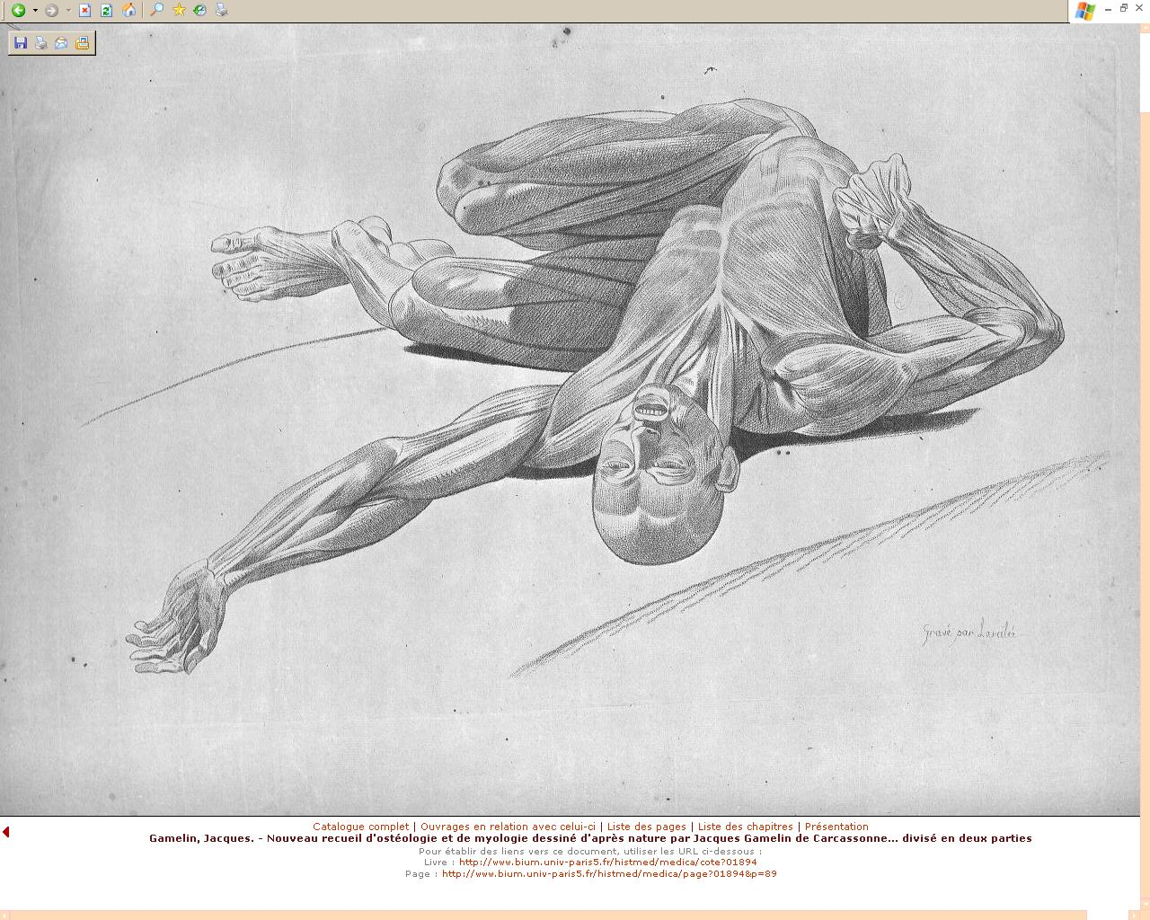
Fig. 5: Jacques Gamelin. Nouveau recueil d’ostéologie et de myologie d’après nature…
URL of this document: http://www.bium.univ-paris5.fr/histmed/medica/page?01894&p=89
Medic@: http://www.bium.univ-paris5.fr/histmed/medica.htm
Web services for the general public
They include all that I have described above, and a serie of permanent virtual exhibitions:
- 100 frontispices de livres de médecine du XVIè au XIXè siècle (http://www.bium.univ-paris5.fr/expo/ )
- Le voyage en Italie de Jules Cloquet (http://www.bium.univ-paris5.fr/cloquet/)
- Les gueules cassées (http://www.bium.univ-paris5.fr/1418/)
- L’herbier de Paolo Boccone (http://www.bium.univ-paris5.fr/boccone/)
- Les monstres de la Renaissance à l’âge classique. (http://www.bium.univ-paris5.fr/monstres/ )
Two other exhibitions are on the way: a second exhibition on the theme of monsters, and, in collaboration with the Collège de France, a rather large collection of photographic plates by Etienne-Jules Marey.
Cooperation
It is the interest of our patrons and of our library to develop strong partnerships, in France and abroad.
From this viewpoint, it is a major aim for us to set up an OAI-PMH compliant repository. It will be done by the end of this year. The first consequence for the users will be that Medic@'s documents will be searchable via Gallica (http://gallica.bnf.fr/ ), the French National library's digital library, and that Gallica's medical documents will be retrieved via Medic@. It will build a 7000 documents library.
I may mention that Medic@ was preselectionned to participate in the European digital library project, even if it is too early to say if it will be set up.
We hope that OAI-PMH will be an efficient tool to help us in developing an active partnership with the NLM. The very encouraging contacts we already have with the History of medicine Division let us hope that we shall build a real cooperation. We wish it very much, and we think that it is the good way towards an international network for the history of medicine.
Other institutional collaborations are already set up in France, with the Académie nationale de médecine, the Académie nationale de chirurgie, the Collège de France, the Ecole nationale vétérinaire d’Alfort, the Centre d’études supérieures de la renaissance, the Institut de recherche et d’histoire des textes.
Conclusion
We have already build a bit of the place for the history of medicine that we think is necessary on the Internet. We know very well that we cannot do it all by ourselves. Developing efficient cooperations is what we seek.

