Increasing information literacy at NTNU and St.Olavs Hospital: implementation of an e-learning tool
Karen Johanne BUSET, Research Librarian, NTNU Library / St Olavs Hospital, Trondheim, Norway, karen.buset@ub.ntnu.no
Sigvor KVALE, Research Librarian, NTNU Library, Trondheim, Norway, Sigvor.kvale@ub.ntnu.no

This paper describes the implementation of the e-learning tool – VIKO – at the Norwegian University of Science and Technology (NTNU) and St.Olavs Hospital – Trondheim University Hospital.

Introduction
Why did the Norwegian University of Science and Technology (henceforth NTNU) Library feel the need to develop a tutorial in information literacy?
In order to increase the quality of higher education in Norway, the Norwegian Parliament implemented the national Quality Reform programme in 2001.This programme focuses on the promotion of problem-based learning and active student participation. Students are expected to write several papers throughout the term, in addition to traditional exams, and are expected to find and use information from various sources.
Consequences for the library include increased demand for library services, for help in finding adequate information, and for user education. The library had to change move its focus from traditional reference services to user education; thus encouraging students to become ‘information literate’, and thereby help them gain the skills required to locate sources of information, as well as evaluate, select and use them. We saw the need to provide a tool to increase the students’ information literacy, and to reach all students irrespective of library opening hours; in response to this, we decided that a web tutorial in information literacy was a suitable tool. In 2003, the NTNU Library started The VIKO Project in order to create an interactive tutorial in information literacy.
The institutions

NTNU is the second largest university in Norway. Fact and figures:
- The university awards professional degrees in medicine, psychology, fine arts and music, teacher education.
- NTNU offers a wide selection of programmes in arts and aesthetics, as well as the humanities, social sciences, economics and public and business administration.
- 7 faculties, 53 departments.
- 20,000 students, 10,000 studying technology or the natural sciences, 700 studying medicine.
- 3000 degrees awarded each year: 1,100 bachelors, 1,700 masters and 220 PhD degrees.
- 4,300 staff, Medical faculty 650. 50% academic or scientific positions.
- Participates in the European Commission’s 5th and 6th framework programmes. Partner/coordinator of 135 projects.
- Annual budget NOK 3.6 billion (approx. USD 500 million).
The NTNU Library is Norway’s oldest academic library, dating back to 1768. The Library has a collection of 2.7 million printed volumes, 21,000 electronic books and 7,900 electronic journals. The Medical Library is a subsection of NTNU Library, and serves both NTNU and St. Olavs Hospital.

St. Olavs Hospital, Trondheim University Hospital, is the regional hospital for the Central Norway. The University Hospital in Trondheim is the first university in Norway to integrate patient treatment, research and teaching. Key data 2005:

- Patient days, somatic: 332,670
- Patient days, psychiatric: 101,343
- Beds, somatic: 1,053
- Beds, psychiatric: 313
- Staff: 8,691
- Annual budget (in 1,000 NOK): 5,108,442

VIKO

VIKO (Acronym for “Veien til Informasjonskompetanse” i.e. “Your Guide to Information Literacy”) is an interactive course in information literacy designed for students at NTNU. Consisting of seven different modules, the course provides help in searching for information and writing papers. VIKO can be implemented as part of other library and university courses. VIKO also includes a two minute “trigger” video.

VIKO aims to:
- Enhance information literacy at NTNU and St.Olavs Hospital
- Increase quality of students’ performance
- Replace basic-level user education
- Teach students essay writing and source evaluation techniques
- Support teachers in student tutoring
- Prevent plagiarism
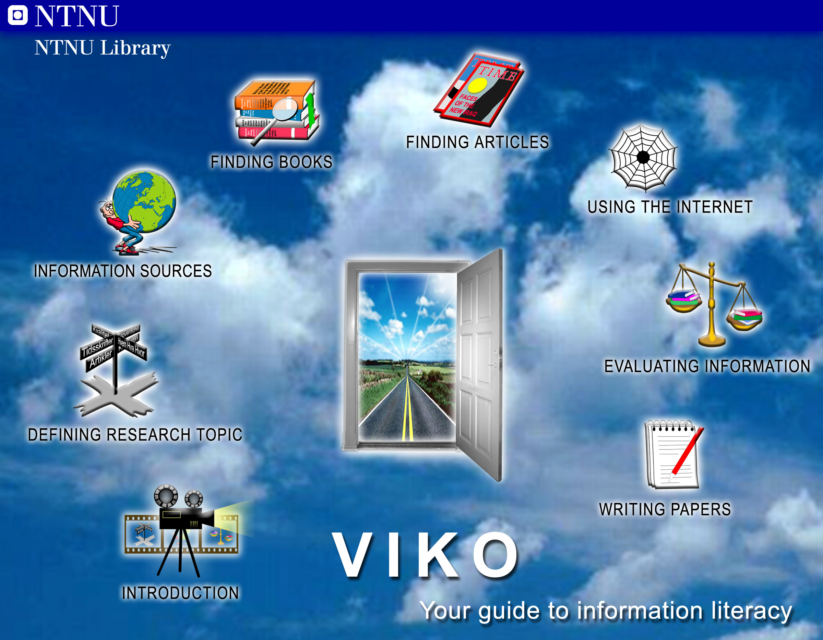
Fig. 1 The VIKO Website

The modules and their component parts present ways to navigate through the information flow, and provide practical tools for finding literature, evaluating the quality of the information and writing papers and references. VIKO Modules:
- How to define a research topic
- How to find relevant information sources
- How to find books
- How to search databases for articles
- How to use the web to find information
- How to evaluate information sources
- How to write papers and cite references

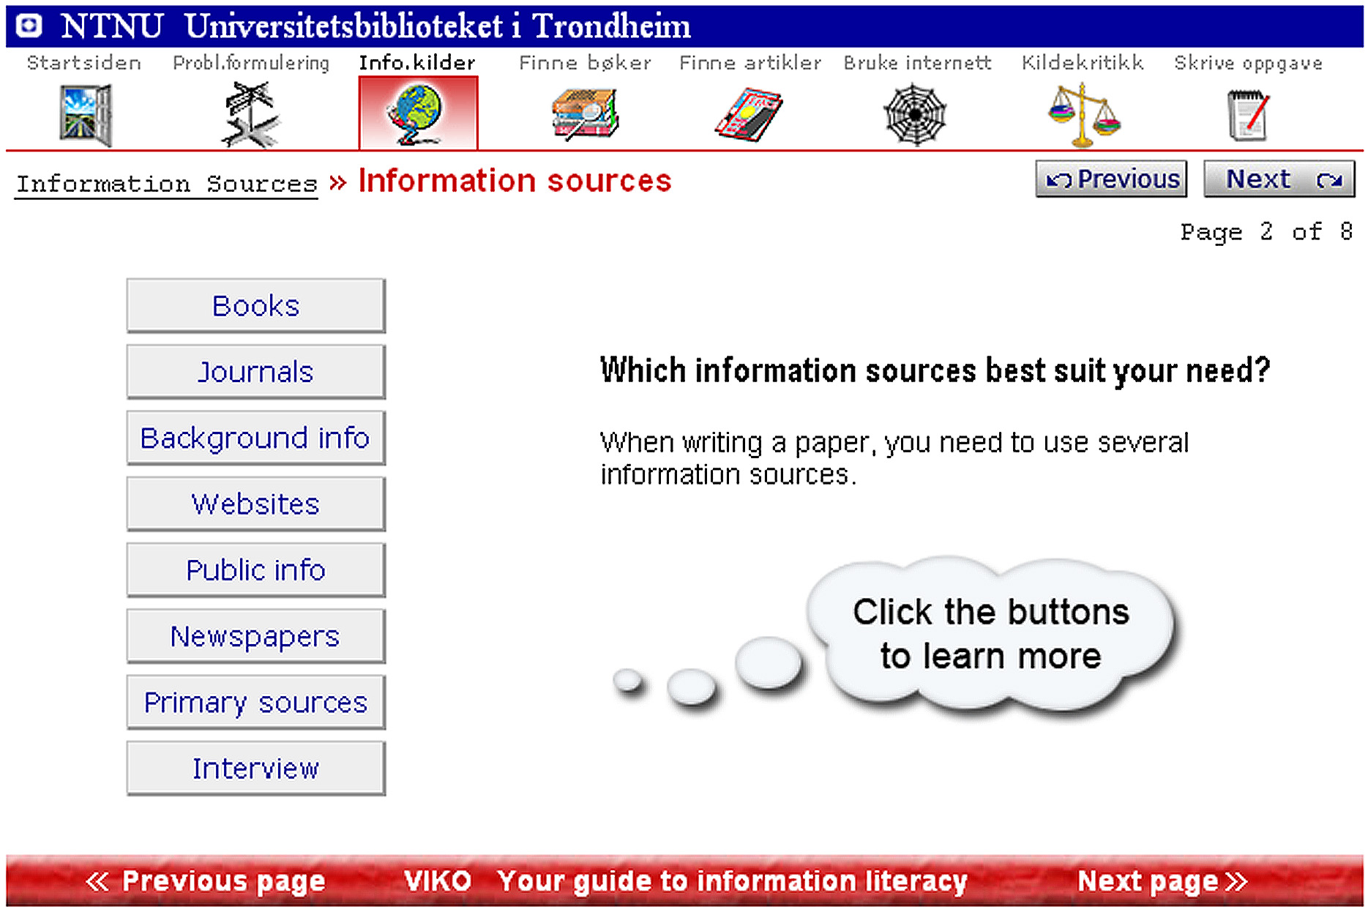
Fig. 2 Example from the module Information sources

The project

The VIKO project started in May 2003, and VIKO version one was completed 1st July 2004. The project group consisted of three persons, in addition to four co-workers who helped designing and writing the tutorial. Additionally, the project group included a reference group of 4 persons from various sections of the library. Two usability tests were carried out, based on Jakob Nielsen's “Usability test” http://www.useit.com/alertbox/20030825.html
The project was financed by the Norwegian Archive, Library and Museum Authority and NTNU.

VIKO is an in-house project designed and developed at the NTNU Library.

Implementation

In order to make VIKO known to students and teachers we had to market the tutorial in such a way as to create interest for future users. Various attempts were made to prepare the implementation of VIKO at NTNU. We were interviewed in the University newspaper a few weeks before VIKO was launched, and the trigger movie was linked from the NTNU website and shown in various forums. We also wrote promotional material – including brochures, bookmarks, etc. – to support the promotion of VIKO for teachers, students and reference librarians
Our strategies for implementation:
- Implement VIKO in user education at the NTNU Library
- Introduce VIKO for health care professionals at St.Olavs Hospital.
- Make VIKO part of the Teaching Assistant Program at NTNU
- Integrate VIKO into NTNU’s e-learning platform

Integration of VIKO in user education at the NTNU Library.

In 1996, The Medical School of the University of Trondheim, The Norwegian National Institute of Engineering (NTH) and The College of General Science merged to create NTNU. NTNU Library was formed by a merger of libraries from the three institutions. Each institution had its own library which had its own culture and ways of performing the various library functions. NTNU Library is now decentralised, and has branch libraries on the two main university campuses and at St Olavs Hospital.

To help bridge the gaps between the libraries, matrices were created across the organizational structure. The matrices are organised according to common functions in the library, cataloguing, inter-library loan, circulation, user education, etc. The matrix for user education’s purpose is to assist research librarians in coordinating and developing the NTNU Library’s user education programme. User education is decentralised, and provides teaching according to requirements of the different subject areas.

The NTNU Library places emphasis on user education, and supports efforts from the subject specialists and the user-education matrix to incorporate user education in the curriculum. To help provide a common approach to user education, we created VIKO as a tool in information literacy for all new students regardless of discipline/subject. We asked the matrix for user education to help us promote VIKO, and we presented VIKO to all librarians involved in user education at the branch libraries. The Library Director supports the process of incorporation of VIKO into the Library’s user education programme – and into NTNU’s curriculum – and continues the effort towards making VIKO compulsory for new students at NTNU.

In June this year, we asked the matrix for user education to appraise strategies and methods for incorporating VIKO in NTNU Library’s user education. The aim of the survey is to incorporate systematic use of VIKO in NTNU Library’s courses and classes, starting in autumn 2007.

The survey will consist of a small team of library instructors from both campuses who will look in to:
- The use of VIKO in current/existing user education
- Various models for use of VIKO in user education, for example:
  - Private study of VIKO before taking the information literacy class with or without a preliminary introduction by a librarian.
  - Systematic use of VIKO during the course

The team will present the results from the survey to the matrix for user education, and also evaluate the different models for incorporating VIKO in NTNU Library’s courses and classes.

Introduce VIKO for the healthcare professionals at St.Olavs Hospital

Healthcare professionals are an important group of users at the Medical Library; one third of St. Olavs Hospital staff is nurses. We have observed increasing use of library resources by this group, and also the need for help in finding information. In our opinion, this is a result of increasing use of project-based organisation of hospital activity, and demands for skills-development and continuing education for all staff. The hospital has its own training section, but does not provide classes in library skills/information literacy.

Nurses have experience and clinical expertise through their practice, but many of them need support to find relevant information sources and literature. To solve this, they need to increase their information literacy. By using evidence-based approaches in library courses, nurses can use their work experience and expertise to find and evaluate new information. Evidence Based Nursing (EBN) is the process by which nurses make clinical decisions using the best available research evidence as well as their clinical expertise. The process involves a number of steps:
- Identify a question or problem
- Find the best available evidence by search the literature for relevant research
- Evaluate the research evidence using established criteria
- Apply the results to a specific population
- Evaluate the outcome

We consider information literacy as important for EBN training; however, we see two problem areas in increasing information in healthcare professionals:
- nurses and other healthcare professionals have no time to attend courses during working hours
- the medical library does not have enough recourses to offer classes to all healthcare professionals

By using VIKO we can reach all our users; we see different approaches:
- Through regular library training classes; we will offer courses specially designed for this user group, based on EBN and with systematic use of VIKO during the course
- Through courses at hospital departments , with examples and exercises tailor-made for the department – also based on EBN and with systematic use of VIKO during the course
- Self-tuition, where nurses (and others) use VIKO during working hours, at the library or at home. This demands promotion of VIKO and introductory courses for St.Olavs Hospital, and we will use experience gained from general promotion at NTNU

Making VIKO part of the Teaching Assistant Program at NTNU

LAOS (Acronym for LæringsAssistentOpplæringSystem i.e. The Teaching Assistant Training System) is a strategic measure aimed to enhance the quality of studies at NTNU. The LAOS project helps the NTNU education strategy comply with the requirements of the Quality Reform; the aim for this training system is to promote forms of learning based on dialogue and subject mentoring. Other aims include a) improving guidance for all students through regular feedback during the study year, b) contributing to more student-active forms of teaching, c) increasing the possibilities of developing and implementing new and varied forms of evaluation, d) strengthening student learning in each subject, e) training students in approaches to co-operation.

From autumn 2002, the LAOS project has been academically and administratively based in the university-teaching and teacher-training environment at NTNU, and – in the course of seven semesters – around 650 students have completed this 20-hour training programme. The LAOS project was awarded second prize in the competition for "Utdanningskvalitetspris" (Education quality award) arranged by the Ministry of Education and Research in 2005.

LAOS is an important link between students and teachers, and the teaching assistants have the closest and most frequent contact with the students at beginner level. We therefore considered LAOS as a good starting point for promoting VIKO directly to the students and future users of VIKO. We used both formal and informal ways in approaching the institution to implement VIKO. Regarding LAOS it was the informal way that gave us a breakthrough. Presenting VIKO to key persons in the system, and trying to convince them that students and teachers would benefit from using the tutorial proved to be successful. Word went around, and we were asked to present VIKO to the teaching assistants at The Department of Art and Media Studies. The department wanted to use VIKO for beginner students, and asked us to give the teaching assistants instruction on how to use VIKO. We also had a short presentation for the beginner students. Next term we were told that they didn’t any need introduction, because VIKO was self-explanatory and easy to use.

Integration with it’s:learning – NTNU’s Virtual Learning Environment

Our challenge is to reach the students with information about VIKO at the right time in their study program. Our goal is to integrate VIKO into courses; therefore it’s:learning – NTNU’s Virtual Learning Environment (VLE) – seemed a natural channel of information. We already had close relations with Multimediesenteret, the department responsible for support and development of the VLE.

it’s:learning http://www.itsolutions.no/ is a web-based VLE and forms a framework for the resources used in the learning process – including persons, topics and processes. All employees and students at NTNU have access to it’s:learning, and it is integrated with NTNU’s intranet and other student ICT-systems. We have not established library training as a separate course in it’s:learning: we consider it more useful to integrate VIKO as a learning resource in the courses. This must be done by the teacher responsible for the course.

Status July 2006:
- VIKO is linked from it’s:learning’s homepage, and is available for all teachers and students. VIKO is also promoted as help in writing papers and literature searches.
- VIKO is recommended in it’s:learning classes for teachers, and teachers are offered help to link VIKO from their courses.

We will find solutions to make it easier for the teachers to integrate VIKO in their courses; this will be done in relation to the development of subject guides (see below).

Results

VIKO is widely used in classes and courses at NTNU, and is also recommended in guidelines for essay writing. VIKO is also recommended – by NTNU’s legal adviser – for teachers to help prevent plagiarism. We are going to focus on the two most important results of the use of VIKO at NTNU:

- Improved quality of student papers
- Increased use of VIKO during term

Improved quality of student papers

VIKO has been used successfully in introductory classes for new students, resulting in increased quality in academic writing, citation and bibliographic referencing.

In the autumn term 2004, VIKO was implemented in the preparatory courses at the Department of Art and Media Studies. This is the largest preparatory course at NTNU with 400 students. The teachers and teaching assistants emphasised the importance of academic writing, and submitted papers displayed significant improvement in quality of citation of bibliographical sources. External reviewers have also commented upon this fact. The programme director, Stig Kulseth, considered this to be a result of the implementation of VIKO in the course.

Increased use of VIKO during term

Since VIKO was launched in 2004, we have seen increasing use of the tutorial during term time. We use WebTrends http://www.webtrends.com to analyse the access information regarding the activity on the library web-server. This gives us statistics for use, interesting data are:

- Most Requested Pages: Displays the most popular Web Site pages and how often they were accessed
- User Session: A period of activity (all hits) for a unique user of a website.
- Most Active Organizations

Statistics show increasing use of VIKO during term. The activity corresponds with the periods when students write their papers. The user session statistics also shows that the total use of VIKO is increasing.

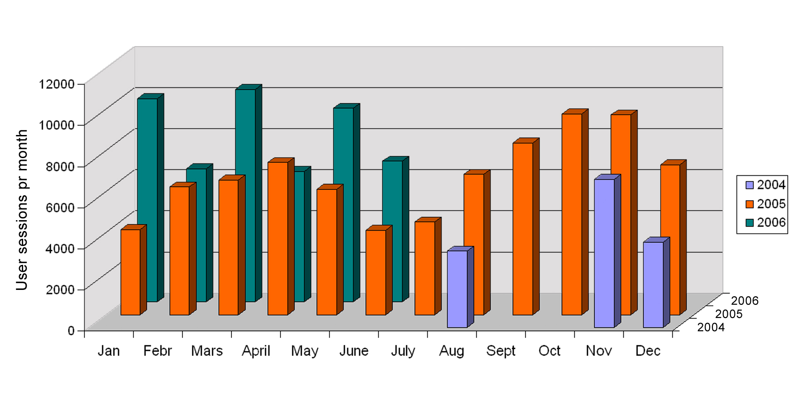
Fig. 3 Activity: User sessions per month

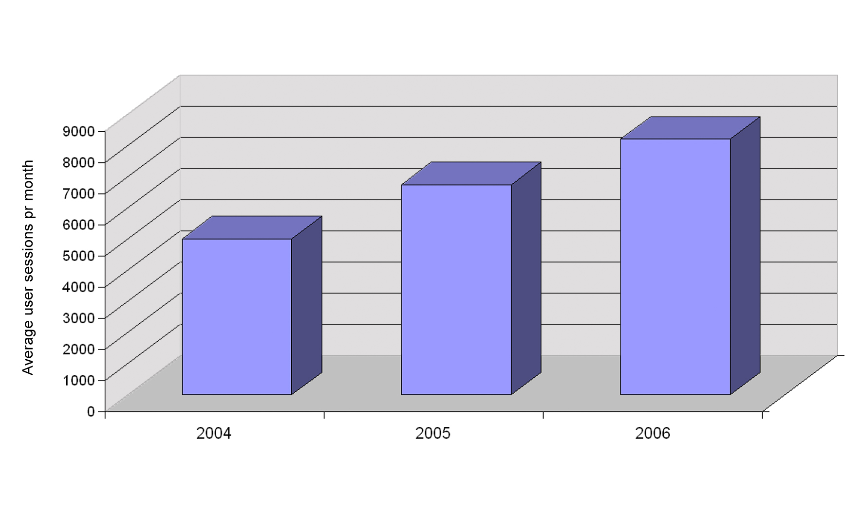
Fig. 4 Activity: Total use of VIKO

Statistics of “Most Active Organizations” also shows that VIKO is widely used in higher education institutions in Norway.

Experiences from integration and use of VIKO at NTNU

VIKO has, however, not been in use long enough for us to refer to statistics, and to have carried out evaluation tests of the effects and benefits of using VIKO at NTNU. What we do know is that, where VIKO has been evaluated, it has definitely had a positive effect, like the positive results from the Department of Art and Media Studies. Teachers, who know of VIKO, like it and recommend it to their students. Older students tell new students that VIKO is good and gets you better grades, as well as helping save time in information retrieval and paper writing

We are planning to carry out a survey to evaluate the effects and benefits of the use of VIKO at NTNU.

Future strategies and developments

- Developing subject guides
- Make VIKO accessible for students with disabilities

Developing subject guides

We have been asked by teachers, students and librarians to create subject-specific guides for VIKO for advanced students, and a pilot project is underway to develop a prototype for VIKO subject guides

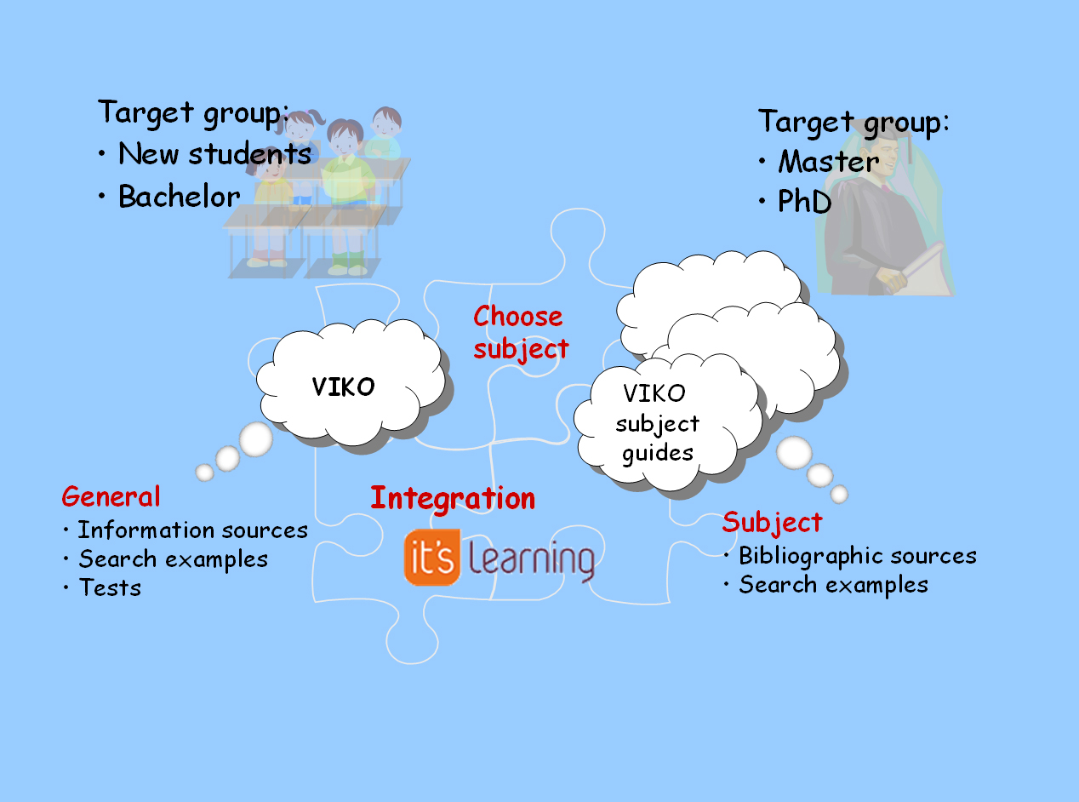
Fig. 5 Connection between VIKO and VIKO subject guides

The subject guide can be used as a course in information retrieval within a subject, and also as a practical tool in finding information sources and getting help in using them
Students’ learning outcome after completing VIKO subject guide: after completing the guide the student should:

- Be familiar with the bibliographical sources within the subject
- Be able to identify, analyse and critically evaluate information resources, where to find them and how to use them

The pilot project started this summer, and will be completed in 2007.
Phase 1:
- Examining subject guides from other University libraries in USA, UK and Scandinavia
- Workshop with subject specialist to discuss which elements a subject guide should contain
- Creating a plan for the structure of subject guides and the subject guides relation/interaction with VIKO and the Library’s subject resources(see graph)
- Meetings with all of the library staff who take part in user education, where we presented our plans and got positive feedback
Phase 2:
Developing 2 pilot guides, one in Scandinavian Studies and one in Health Education
- Creating the contents
- Use Master’s Students for feedback and testing
- Finalising the graphic design
- User test
- Second user test after implementing changes according to feed back from test persons
- Demo version
- Evaluation by subject specialists and the matrix for user education
- Launching the VIKO subject guide in Scandinavian Studies and Health Education
- Make templates and tools for subject specialists to create VIKO subject guides

Make VIKO accessible for students with disabilities

NTNU aims to ensure that students with disabilities have the same rights and opportunities as other student in higher education. NTNU will emphasise physical, pedagogical and social accessibility, and has established “Office for students with disabilities” to ensure accessibility to buildings and studies for these students.

To increase information literacy at NTNU, we also offer library classes to students with disabilities. The library must provide special equipment and adjust the library resources to meet the needs of disabled students. The library instructors need qualifications to teach them in a suitable way. If we make VIKO accessible for these students, we will both have a tool for self-tuition, and a tool to use in classes.

Our starting point was to adjust VIKO for the visually impaired. We had VIKO tested by SIKT – the Norwegian ICT-centre for the Visually Impaired. The results showed that most of VIKO was accessible and useful to the visually impaired

We are upgrading VIKO, and want to make the new version of VIKO accessible for all, using the principles of universal design. Universal design, or "design for all," means that products, services and environments are designed to be usable (without modification) by as many people as possible, regardless of age, ability or other factors.

Web accessibility means that people with disabilities can use the Web, more specifically that people with disabilities can perceive, understand, navigate, and interact with the Web, and that they can contribute to the Web. Web accessibility encompasses all disabilities that affect access to the Web, including visual, auditory, physical, speech, and neurological disabilities. Designing websites with accessibility in mind can enhance usability for all users.
The Web Accessibility Initiative (WAI), part of the World Wide Web Consortium (W3C), was established to oversee the development of Web accessibility. The WAI develops guidelines for Web accessibility; support materials to help understand and implement Web accessibility; and Web accessibility resources. http://www.w3.org/WAI/

‘To do’ list for VIKO:
- Identify and follow standards, important standards are
  - WAI recommendation
  - HTML
  - CSS (cascading style sheets)
- Work out an accessibility statement to describe the features to incorporate into the site to aid accessibility for all users, for instance
  - that links have title attributes
  - images have descriptive ALT attributes
  - use of cascading style sheets for visual layout
  - tab indexing
  - use of access keys
- Review all VIKO web pages (coding, scripts, menus, functions) both manually and using automatic code-testing
- Include users with disabilities in usability testing.

This will ensure that all students have the same opportunity to increase their information literacy, and the library has a tool to use when teaching students with disabilities.

Conclusion

- Response from students and teachers confirms that VIKO is useful and meets the users needs
- Integration in and co-operation with the teaching institution is mandatory
- A product that meets an important demand can enhance collaboration between library and academic staff
- VIKO frees time for academic staff in connection with instruction by providing a tool for information retrieval and writing academic papers.
- VIKO has freed library resources in reference work and user education

