Scientific production from the Spanish information and documentation workshops in health sciences (june 1986 - september 2001)
C. Burgos-Fernández, A. Fernández-Luque, T. Bullejos de la Higuera, C. Rivas Ramos
Sistema de Información Científica de Andalucía (Granada), Hospital Comarcal de la Axarquía (Malaga), Hospital Virgen de las Nieves (Granada), Hospital Comarcal de Motril (Granada).

Abstract:
The Spanish Information and Documentation Workshops in the Health Sciences (JEIDCS) have been (and still are) a meeting point for the professionals to share experiences and expectations to meet the challenges of the Knowledge Society. From 1986 to 2001, nine workshops have been held. (Total of papers presented: 334. Total of authors involved: 357, Total of centres represented: 224.)
This article analyses the scientific output from the papers presented during nine editions of JEIDCS. To this end, a bibliometric and bibliographical analysis has been carried out to examine indexes and thematic associations, authors and works in collaboration, scientific output quality, output by autonomous regions and place of work and evolutionary analysis of preferred topics.
The information sources used consist of the proceedings published for each one of the workshops held and the CD-ROM of the proceedings of the nine workshops published by the Institute of Health "Carlos III".
The analysis of the different indicators and the exploitation of data were performed using the bibliographical software "ProCite" and the DBMS "MS-Access", and STATGRAPHICS Plus.
The most outstanding conclusion being that the professionals from the Spanish biological and medical libraries taking part in the workshops were very aware both of the importance of the new information and communications technologies and the need to develop strategies to increase the effectiveness and efficiency of library services in the new technological environment.

Presentation

This research is based on the production of the librarians of medical sciences, with the data obtained from all the contributions published in the Proceedings of the nine Workshops on Information and Documentation in Health Sciences, held in Spain between 1986 and 2001, in CD-ROM format. Consequently, it does not include the contributions which were presented in an oral way but which were never published in the respective proceedings.

The typology of those contributions is variable. The table below shows the amount of them in every workshop:

 | CONFERENCE PAPERS | PAPERS | FORUM | PRESENTATION | POSTER
I Jornadas – Santander (June 1986) | 3 | 15 |  |  |  | 18
II Jornadas – Barcelona (October 1987) | 3 | 30 |  |  |  | 33
III Jornadas – Sevilla (March 1990) | 6 | 30 |  |  |  | 36
IV Jornadas – Bilbao (June 1992) | 5 | 19 | 3 |  | 2 | 29
V Jornadas – Palma de Mallorca (May 1994) | 2 | 40 |  |  | 9 | 51
VI Jornadas – Madrid (November 1995) | 2 | 30 | 5 |  | 4 | 41
VII Jornadas – Granada (November 1997) | 9 | 14 |  |  | 4 | 27
VIII Jornadas – Santiago de Compostela (November 1999) |  | 28 | 9 | 2 | 6 | 45
IX Jornadas – Caceres (September 2001) | 12 | 32 |  | 2 | 8 | 54
Total | 42 | 238 | 17 | 4 | 33 | 334
Table 1. Types of contribution in the Proceedings

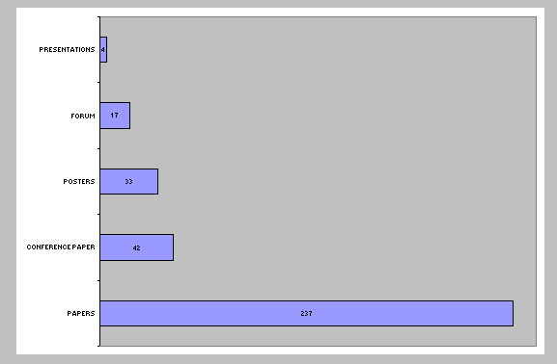
TYPOLOGY | TOTAL
PAPERS | 238
CONFERENCE PAPERS | 42
POSTERS | 33
FORUM | 17
PRESENTATION | 4
TOTAL | 334
Table 2. Types of contribution in absolute terms

Papers are the most common documental typology, with more than 70% of the total amount.
Concerning Posters, their poor presence is probably due to their late introduction in 1992.

WORKSHOPS | TOTAL
I WORKSHOPS | 19
II WORKSHOPS | 33
III WORKSHOPS | 36
IV WORKSHOPS | 29
V WORKSHOPS | 41
VI WORKSHOPS | 51
VII WORKSHOPS | 27
VIII WORKSHOPS | 45
IX WORKSHOPS | 55
TOTAL | 334
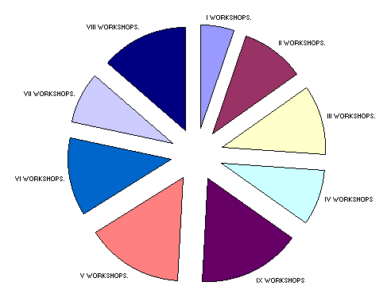
Diagram 1. Partial rates on nine workshops

A database has been created with the bibliographical registers, since they are an excellent tool to know the outlines of the research or the fields of special interest for many librarians and information managers working in the area of health sciences, during the period of time in which the nine workshops were held.

Methodology

The data containing the electronic version of the proceedings were transferred by means of the Software Procite, a powerful tool whose useful applications helped us to transmit the information to a relational database. This gave us the possibility to extract absolute values from the different fields.

It is necessary to work with a master chart, obtained to individualise the authors of every bibliographical registration and to correctly assign the working place as well as the topics associated with each contribution. The primary fields are: registration number, authors, working place, title, first page, last page, type of document, conference and topics.

The fields author, working place and topics were normalised and a file to assign the Spanish autonomous regions and foreign countries was created.

To assign the topics we respected the assigned origin registration by means of a previously coordinated classification with CINDOC, a thesaurus that allowed us to study the topics and their evolution.

The total counting, together with the assignment of every contribution in every single proceedings was made with the associated information of institution and autonomous regions, needed for the studies of collaboration amongst authors, institutions and geographical areas. Following the multiple counting method, we could assign to each author the contributions belonging to different authors and centres. The mixed centres have been taken as single ones.

The groups are:

- By autonomous region: MADRID, ANDALUCÍA, CATALUÑA, VALENCIA, PAÍS VASCO, GALICIA, CANTABRIA, EXTREMADURA, ISLAS BALEARES, ARAGÓN, ASTURIAS, CASTILLA LA MANCHA, CASTILLA LEÓN, MURCIA, NAVARRA, CANARIAS. The foreign countries, with the remarkable presence of Portugal and Brazil and their multiple contributions in the different proceedings are also included.

- By institution: medical libraries, university libraries, national libraries, documentation agencies and foundations.

The following variables have been taken to account for the classification: the temporal, the institutional, the topic and the geographical variable.

The choice of those variables is justified by the need of defining the levels of data aggregation or accumulation that allow pertinent comparisons amongst the different regions and institutions both national and overseas, while offering the opportunity to cross-reference in order to be more self-explanatory.

The institutional sub-groups made for this bibliometrical analysis have been developed taking in account the working centres of each author signing the contribution. The choice of the institutional typology is due to the need of concentrate in the smallest number of centres, with plane names, in order to avoid the chance of error.

The level of political analysis was carried out from the point of view of the regions where the working centres are settled, including the international centres that participate with a small number of contributions.

Type of indicators:

The title of the documents is one of the most used bibliographical elements in the prospective studies. The dynamic analysis that sets the value of the presence of new terms allow the identification of emerging research outlines and fields. Also the term frequency as well as the relationships established amongst the different words facilitate the identification of research outlines and to associate documents by proximity between the words used in the titles.

The variable Authors identifies the writers signing a paper through their surname and name. We have already solved the big and sometimes unavoidable problem of homonyms and variations in an author’s signature. The original database registers them in a near normalised way, so that it is possible to identify those variations to the naked eye, before the future normalisation.
The study of the authors and their contributions in the same bibliographical register will give us the opportunity to conduct research on collaborations, to identify working groups and the most productive institutions…

Even if our source is limited -the proceedings of the nine workshops- it is an adequate indicator to know the general evolution of the subjects and the progress of certain authors in different publications.

The topics have been assigned by means of a Thesaurus from the CINDOC, a pre-coordinated classification that help us to study the subjects and their evolution. We used the normalisation of the primary registers.

The documental typology shows a significant variety and we have found that researchers publish and release their studies and scientific improvements through two different documental typologies: the article in specialised magazines and the paper in congresses. The mentioned sub-groups are present in our database.

The professional position or the working place facilitate the analysis of the geographical and institutional distribution of the production. This field is connected to the author’s and therefore likely to be analysed in a similar way, at a different level.

Results

REGION | TOTAL |  | RATE %
MADRID |  | 167 | 29,24
ANDALUCÍA |  | 102 | 17,86
CATALUÑA |  | 98 | 17,16
VALENCIA |  | 43 | 7,53
PAÍS VASCO |  | 32 | 5,6
GALICIA |  | 23 | 4,02
CANTABRIA |  | 16 | 2,8
EXTREMADURA |  | 13 | 2,27
ISLAS BALEARES |  | 10 | 1,75
ARAGÓN |  | 7 | 1,22
ASTURIAS |  | 7 | 1,22
CASTILLA LA MANCHA |  | 6 | 1,05
CASTILLA LEÓN |  | 6 | 1,05
MURCIA |  | 6 | 1,05
NAVARRA |  | 1 | 0,17
CANARIAS |  | 2 | 0,35
NATIONAL |  | 534 | 94,95
PORTUGAL |  | 5 | 0,87
OTHERS |  | 8 | 1,4
ITALY |  | 2 | 0,35
CUBA |  | 1 | 0,17
BRAZIL |  | 8 | 1,4
HOLLAND |  | 2 | 0,35
BRUSSELS |  | 1 | 0,17
UNITED KINGDOM |  | 1 | 0,17
USA |  | 1 | 0,17
INTERNATIONAL |  | 37 | 5,05
TOTAL |  | 571 | 100%
Table 3: Authors by autonomous community. Partial rates on Spanish/Foreign institutions

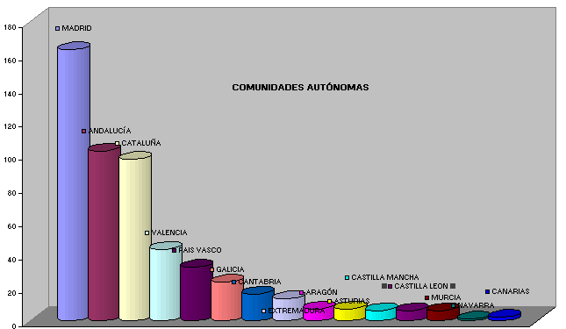

Diagram 2. Representation by Spanish autonomous communities

The highest total figure by region appears in MADRID, that includes state, non-autonomous institutions like the National Medical Library, with 32 contributions, and the CINDOC, with 21. Next in number of authors are Andalusia and Catalonia.
On an international scope, the highest level of contribution is represented by Portuguese and Brazilian authors.

The total of real authors that collaborate in congresses is 357, with between 1 and 10 contributions signed by 571 totally in 336 papers.

The average by contribution is 1.59 authors.

We have noted that 25% of the authors wrote 50% of all contributions in the nine workshops: between 10 and 2 contributions per author.

TYPES OF INSTITUTIONS INVOLVED IN THE CONFERENCIES.

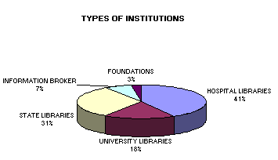
TYPES OF INSTITUTIONS |  | PORCENTUAL
HOSPITAL LIBRARIES | 238 | 41,25
UNIVERSITY LIBRARIES | 177 | 31
STATE LIBRARIES | 102 | 18
INFORMATION BROKER | 39 | 6,75
FOUNDATIONS | 15 | 3
TOTAL | 571 | 100

Diagram 3. Representation by Institutions

41.25% of the papers are presented by hospital librarians, followed by universitary librarians (31%) and state libraries of the central government, CSIC and CINDOC (18%). Only 7% belongs to information broker and 3% to foundation libraries.

The medical librarians have a major presence in the proceedings, with a total amount of 188 contributions.

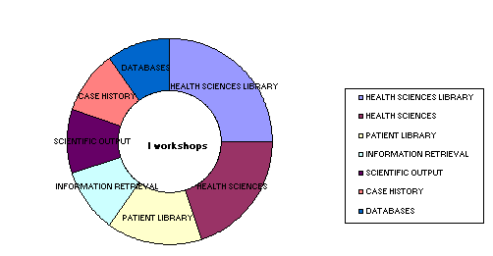
Diagram 4. I Wordshops. Representation by subjetc terms.
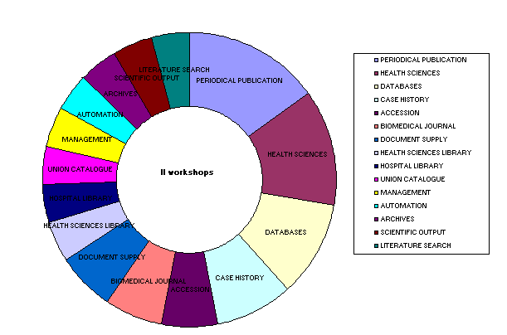
Diagram 5. II Wordshops. Representation by subjetc terms.
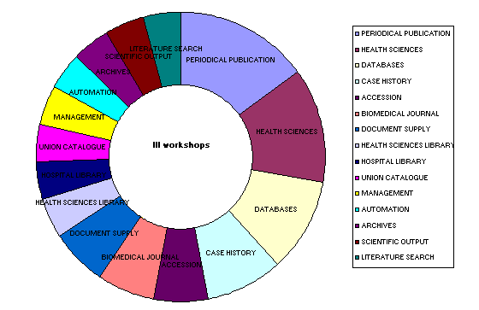
Diagram 6. III Wordshops. Representation by subjetc terms.

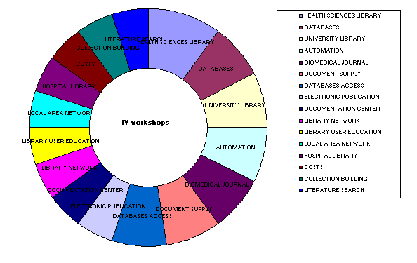
Diagram 7. IV Wordshops. Representation by subjetc terms.
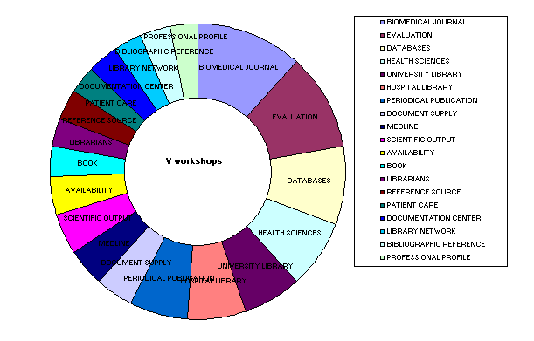

Diagram 8. V Wordshops. Representation by subjetc terms.

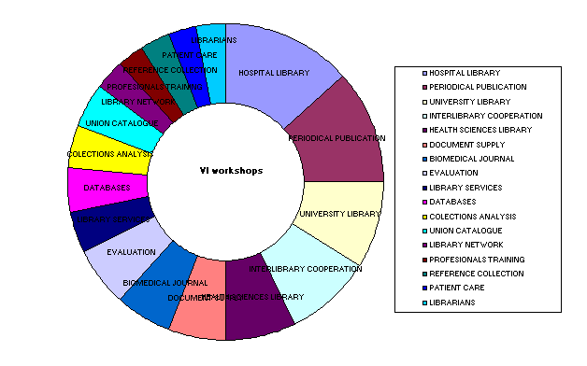
Diagram 9. VI Wordshops. Representation by subjetc terms.
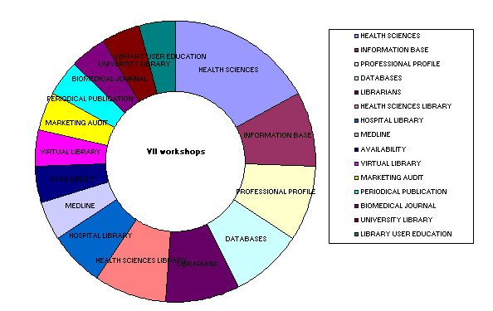
Diagram 10. VII Wordshops. Representation by subjetc terms.

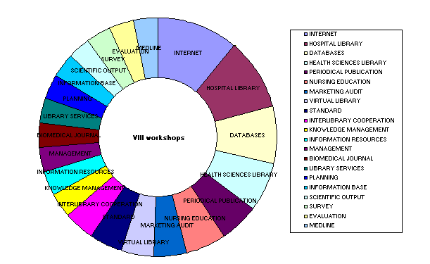
Diagram 11. VIII Wordshops. Representation by subjetc terms.
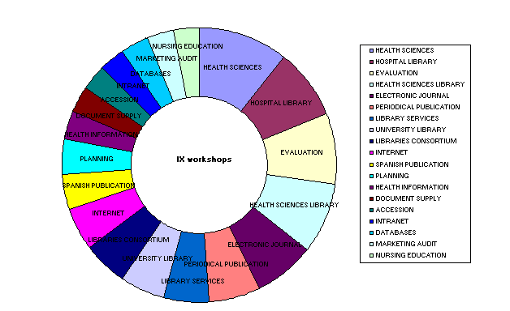
Diagram 12. IX Wordshops. Representation by subjetc terms.

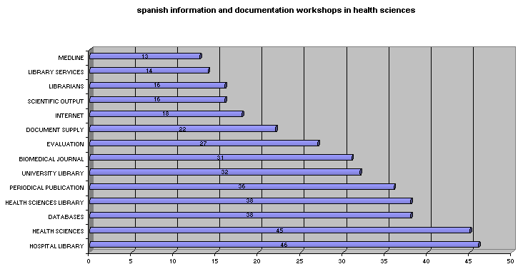
Diagram 13. Representation by subjetc terms

In the analysis of the content of the records we can see that the authors constantly reflect on the role that the medical library plays to provide clinical assistance support, health staff training and medical research. (Most of the papers are connected with the topics 'hospital libraries', 'health sciences' and 'health sciences libraries').
They are also concerned with the evolution of the role requested by the healthcare staff to the library, intimately related to the socio-economic and technological changes in the society. (CD-ROM, Hypertext, Internet, Related terms, Database, interrogation Languages, etc.).
We can also see a constant increase in the number of communications presented which are concerned with the topic of 'Information and Communication Technologies'. (Databases, electronic journals, Medline-Pubmed)
An important number of works (36) deal with the professional profile, the professional and scientific qualification of the librarians and their lifelong learning.
Another important group of works can be grouped around the topics 'library services administration', 'information administration' and 'documental treatment under the key words 'planning', 'evaluation', 'library services', 'documents supply' and 'interlibrary loans'.
The treatment and specific evaluation of the journals plays an important role as the main topic in the topics: 'periodic publications', 'biomedical journals', 'electronic journals', 'sources of information'.
'Users training' is a recurrent topic.
The lack of a scientific policy which takes in to consideration the library and promotes it like a centre for scientific documentation assisted by professional librarians, is the reason why dialogues about collective catalogues, standard catalogues, library coordination and networks, library planning and coordination, cooperative subscriptions, etc., do take place.

CONCLUSIONS

· The librarians were very sensitive about technological changes. They provide possible solutions to increase the effectiveness of the library services.

· Conferences continue taking place on a regular basis and they show an increase in interest about this field.

· The conferences are an ideal forum for the information and exchange of knowledge as well as an updating tool about technological innovations and the way to access information and documental recovery.

· The conferences have helped to establish work and learning norms.

· The conferences represent the philosophy, interests and competences of the professionals from the Spanish biological and medical libraries in the context of the scientific community and the healthcare community in particular.

· The conferences have allowed to create communication and information networks among all the libraries of the system.

REFERENCES:

Moya Anegón F, Solís Cabrera FM. Indicadores científicos de Andalucía: ISI, Web of Science. 1998-2001. Granada: Junta de Andalucía, 2003

Gómez Caridad I, Fernández Muñoz MT, Bordons Gangas M, Morillo Ariza F. La producción científica española en Medicina en los años 1994-1999. Rev Clin Esp 2004;204(2):75-88

Jornadas de Información y Documentación de las Ciencias de la Salud. Madrid: Ministerio de Sanidad y Consumo, 2002

Maltrás B. Los indicadores bibliométricos en el estudio de la ciencia. Fundamentos conceptuales y aplicación en política científica: tesis doctoral. Salamanca: Universidad, 1996

Ribes Cot MF, García Martín, MA. Las bibliotecas de Ciencias de la salud Españolas: Pasado Presente y Futuro. En: X Jornadas de Información y Documentación en Ciencias de la Salud. http://www.jornadasbibliosalud.net/ponencias/pon_apertura.doc

