The Role of Librarians in the Genomic Medicine Era
¹ Yarte del Toro, A.; ¹ Veiga de Cabo, J.; ³ Bello Rojo, E; ² Martín-Sánchez, F.
¹Health Sciences National Library, ²Medical Bioinformatics Department. Institute of Health Carlos III,
³Spanish National Cancer Centre.

Madrid, Spain

³

ABSTRACT

The purpose of this paper is to inform librarians about the use of bioinformation stored in databases. Sequencing of the human genome is already finished. The target date for making the complete, high-accuracy sequence available was April 2003, during the celebration of the 50th anniversary of the discovery of the double helix of DNA. The world of biology has been transformed by technical tools of a field known as genomics. These new methods have allowed scientists to generate extraordinarily useful information and they have become dependent on computer science to store, organize, search, manipulate and retrieve the new information. The new discipline of bioinformatics has created many new molecular biology databanks to store the results of the Human Genome Project.

The potential usefulness from this rich databank of current information containing sequence data from humans and model organisms, along with recent technological innovation fostered by the Human Genome Project, will lead to important advances in the understanding of diseases and disorders having a genetic basis and how health care is delivered from this point forwards.

The sequence-based and functional annotations are stored in Databases that hold more than 32,549,400 sequence records as of February 2004. To facilitate the use of databases by the research community, there are two major genome websites: The European Molecular Laboratory (Europe) and the National Center for Biotechnology Information (United States of America).

These portals provide free accessibility to all this basic information, without restrictions, subscription fees or other passwords. The specialized libraries in health sciences have had from their origins, and must continue having, a leading role in the transmission of knowledge amongst the scientific community. Health and Medical librarians can play a key role in making possible the translation of genomic research information into clinical environments. It would be useful for librarians who work in health science libraries to know how to search key genetic information resources and to have a basic understanding about the type of information contained in each one.

KEYWORDS. Human Genome, Health and Medical librarians, Molecular Biology Database, Genetics, Genomics, Bioinformation, Bioinformatician, Bioinformatics, EMBL, NCBI, SRS, Entrez.

INTRODUCTION

The study of biology and medicine has deeply undergone a major transition over the last years , with the public availability of sequences of the genomes of human, mouse, fruitfly, bacteria, virus (SARS) and rapidly growing sequence data on other organisms, providing ready access to databases on nucleic acids, proteins as well as their properties.

All Genome projects are large generating quantities of new genetic information (bioinformation). The new discipline of bioinformatics has created many new molecular biology databanks to store the results of the Genome Projects. The Molecular Biology Databases are freely available to the public (1). There are hundreds and probably thousands of Web sites that can now be accessed through the Internet for browsing, querying, or retrieving molecular biology data and related data sets. This data is expected to be the information source for biomedical science in the 21st century (2). Researchers and medical students need access to this bioinformation. The librarians who wok in health sciences libraries should know to search key genetic information resources and should have a basic understanding of the type of information contained in each database.

These valuable tools which are available for the use of librarians can be located mainly on two websites.

MAJOR PUBLIC INSTITUTIONS

There are lots of web pages with information about genome projects, but a few form a core for access to bioinformatics databanks and tools.
In Europe, the vast majority of the nucleotide sequence data produced is collected, organised and distributed by the European Molecular Laboratory (EMBL) Nucleotide Sequence Database (http://www.ebi.ac.uk/embl.html) located at the European Bioinformatics Institute (EBI) (Cambridge, UK), The roots of the EBI lie in the EMBL Nucleotide Sequence Data Library (3), which was established in 1980 at the EMBL in Heidelberg, Germany and was the world's first nucleotide sequence database. What began as a modest task of abstracting information from the literature soon became a major database activity with direct electronic submissions of data and the need for highly skilled informatics staff. The task grew with the start of the genome projects and, in 1992, the decision was taken to create a new EMBL Outstation dedicated to bioinformatics. The EBI was established on the Wellcome Trust Genome Campus in the United Kingdom, in close proximity to major sequencing efforts taking place at the Wellcome Trust Sanger Institute and the Human Genome Mapping Project (HGMP) Resource Centre.
The EBI fulfils three important functions: it provides some of the world's largest and most heavily used bioinformatics services in a free and unrestricted manner; it carries out research; and it trains the bioinformaticians of the future. We will limit our discussion here to the EBI's databases and their services (Fig. 1).

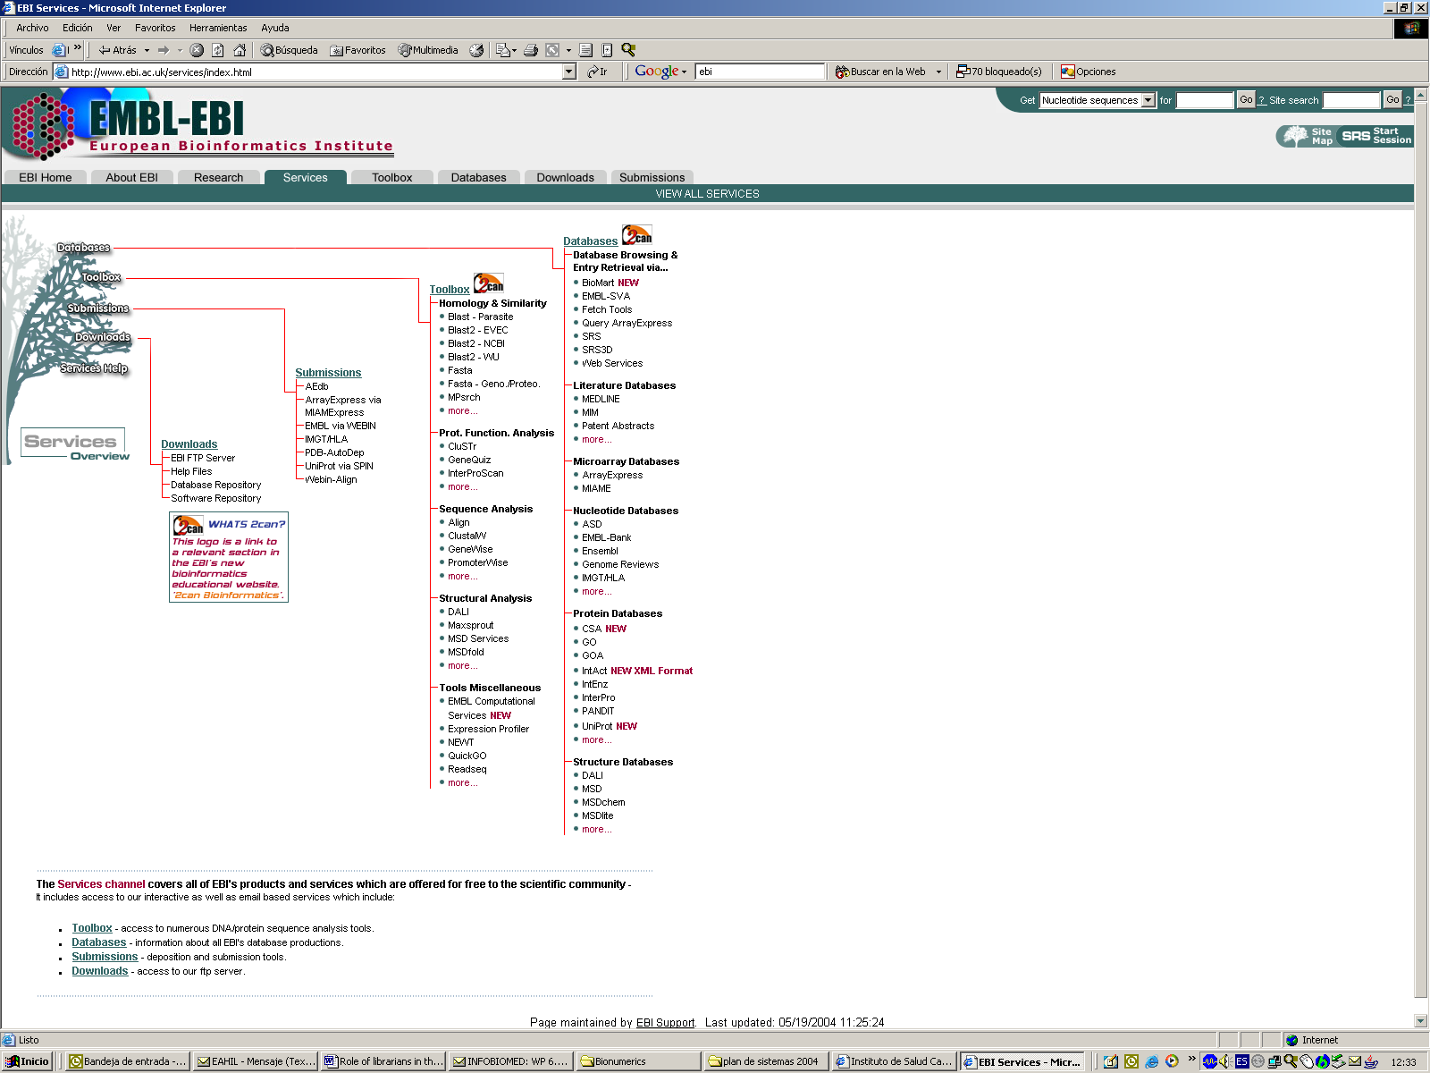

Figure 1. Services of the European Bioinformatics Institute

The six core molecular databases hosted by the EBI reflect the methods used by biologists to collect information on how cells and organisms work. These databases store information on DNA and RNA sequences (EMBL-Bank), protein sequences (SWISS-PROT and TrEMBL), protein structure (MSD), whole genomes (Ensembl) and gene expression experiments (ArrayExpress). All the EBI's databases are annotated: features pertaining to gene structure and transcription mechanisms as well as those describing protein structure and function are also stored in them and are predicted, inferred, interpreted and validated from many sources. Much of this annotation is performed by highly qualified biologists and the automated annotation that the EBI do is subjected to rigorous quality ( 4).

In the United States of America, the National Center for Biotechnology Information (NCBI) at the National Institutes of Health was created in 1988 to develop information systems in the field of molecular biology. In addition to maintaining the GenBank® nucleic acid sequence database, for which the data is submitted directly by the scientific community (5) , NCBI provides data analysis and retrieval and resources (Fig.2). that operate on GenBank data and a variety of other biological data made available through NCBI. The data accessible from NCBI’s home page (http://www.ncbi.nlm.nih.gov) runs the gamut from short sequences representative of parts of genes, such as expressed sequence tags (ESTs), through complete genomic sequences, such as the 21 complete microbial genomes in GenBank today, to phenotypic descriptions such as those found in Online Mendelian Inheritance in Man (OMIM). Protein structures are linked to sequence data through the Molecular Modeling Database (MMDB). To access this data, NCBI offers powerful retrieval and search tools, such as Entrez and BLAST .

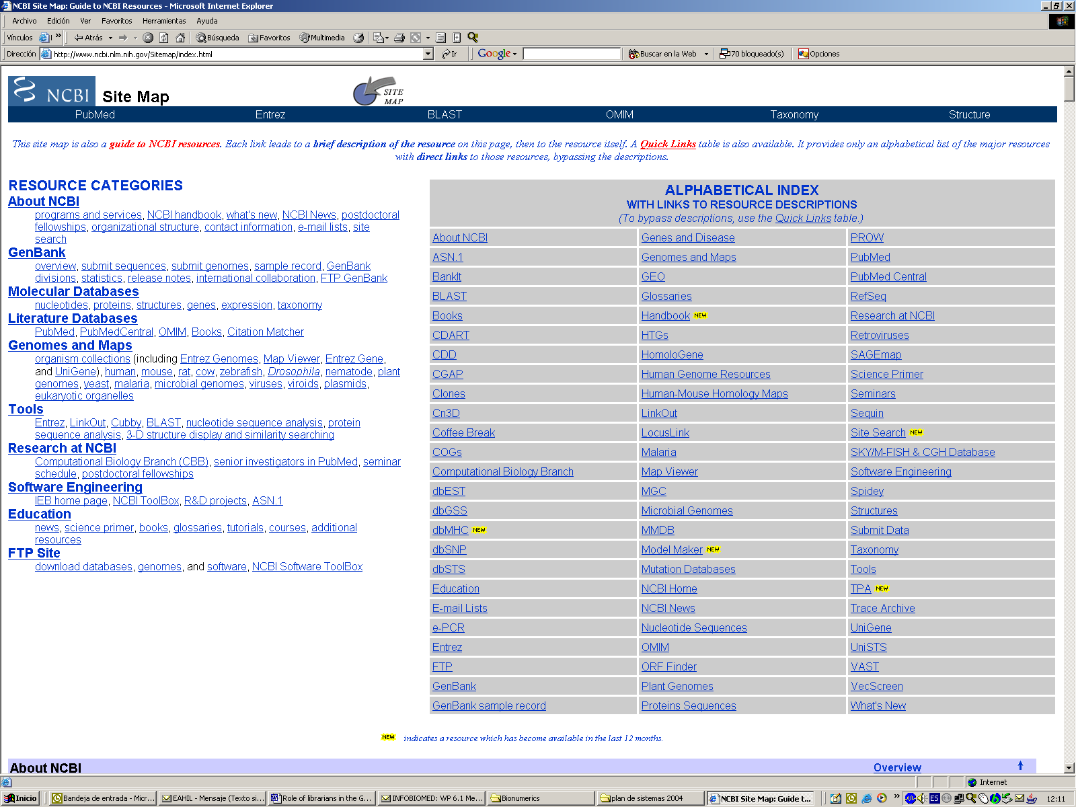

Figure 2. NCBI Site Map. A guide to NCBI resources

DATABASES

There are many types of data generated by molecular biology research:
- nucleotide sequences (DNA and mRNA)
- protein sequences
- 3-D protein structures
- complete genomes and maps
- gene expression
- genetic variation (polymorphisms)

Among the publications and information sources that gather the creation, modification and updating of Molecular Biology Database, the following stand out: The Molecular Biology Database Collection is a public resource listing key databases of value to the biologist, including those featured in the first issue of each year of Nucleic Acids Research (5), and other high-quality databases. All databases included in this Collection are freely available to the public. This listing aims to serve as a convenient starting point for searching the web together reliable information on various aspects of molecular biology, biochemistry and genetics. This year’s (2004) update includes 548 databases, 162 more than the previous one. The databases are organized in a hierarchical classification that should simplify finding the right database for each given task. Each database in the list comes with a recently updated brief description.These can be accessed online at the Nucleic Acids Research web site http://nar. oupjournals.org/.

Database Categories List
Nucleotide Sequence Databases
RNA sequence databases
Protein sequence databases
Structure Databases
Genomics Databases (non-vertebrate)
Metabolic and Signaling Pathways
Human and other Vertebrate Genomes
Human Genes and Diseases
Microarray Data and other Gene Expression Databases
Proteomics Resources
Other Molecular Biology Databases

The DBcat (http://www.infobiogen.fr/services/dbcat) is a comprehensive catalog of biological databases maintained and curated on a daily basis at GIS Infobiogen. It contains more than 400 databases classified by application domains. The DBcat is a structured flat file library that can be searched by means of an SRS server or a dedicated Web interface. The files are available for downloading from Infobiogen anonymous ftp server (6)

The most representative of those database already mentioned are:

THE NUCLEOTIDE INFORMATION RESOURCE

GenBank® (7 ) is the NIH's database of all publicly available nucleotide and protein sequences including supporting bibliographic and biological information. Since 1992 it has been based at the National Center for Biotechnology Information (NCBI), a division of the National Library of Medicine, located on the NIH campus. NCBI was created by Congress in 1988 and specifically charged with developing automated information systems to support molecular biology and biotechnology

The EMBL Data Library in the UK in collaboration with GenBank (NCBI, Bethesda, USA) and the DNA Data Bank of Japan (NIG, Mishima) has been processing nucleotide sequence data reported world-wide since 1982. Genome Project data, direct submissions by individual scientists and patent sequence data from the European Patent Office are the main sources contributing to the ongoing database growth. To achieve optimal synchronisation all the new and updated database records are exchanged between the International Nucleotide Sequence Collaboration on a daily basis.
EMBL Database entries are grouped into divisions. Divisions are subsets of the database reflecting the areas of interest of the user community and are based mainly on taxonomy (e.g. HUM = human, PLN = plants, PRO = prokaryotes, etc.) with a few exceptions like HTG (High Throughput Genome Sequences), GSS (Genome Survey Sequences) and EST (Expressed Sequence Tags) for which grouping is based on the specific nature of the underlying data.

THE PROTEIN INFORMATION RESOURCE
The Protein Information Resource (PIR-International) was established in 1988 as a collaboration between the National Biomedical Research Foundation (NBRF), the Munich Information Center for Protein Sequences (MIPS), and the Japan International Protein Information Database (JIPID). The aim was to collect and publish what is now the oldest database of biomolecular sequence, source, bibliographic and feature information.
Today the Protein Information Resource (PIR) is an integrated public resource of protein informatics that supports genomic and proteomic research and scientific discovery (8). PIR maintains the Protein Sequence Database (PSD), an annotated protein database containing over 283 000 sequences covering the entire taxonomic range. Family classification is used for sensitive identification, consistent annotation, and detection of annotation errors. The superfamily curation defines signature domain architecture and categorizes memberships to improve automated classification. To increase the amount of experimental annotation, the PIR has developed a bibliography system for literature searching, mapping, and user submission, and has conducted retrospective attribution of citations for experimental features.
PIR also maintains NREF, a non-redundant reference database, and iProClass, an integrated database of protein family, function, and structure information. PIR-NREF provides a timely and comprehensive collection of protein sequences, currently consisting of more than 1 000 000 entries from PIR-PSD, SWISS-PROT, TrEMBL, RefSeq, GenPept, and PDB. The PIR web site (http://pir.georgetown.edu) connects data analysis tools to underlying databases for information retrieval and knowledge discovery, with functionalities for interactive queries, combinations of sequence and text searches, and sorting and visual exploration of search results. The FTP site provides free download for PSD and NREF biweekly releases and auxiliary databases and files.

The SWISS-PROT Protein Sequence database

The SWISS-PROT protein sequence database is maintained collaboratively by the EMBL Data Library and Amos Bairoch of the University of Geneva. It is distributed in the same file format as the Nucleotide Sequence database, with which it is fully cross-referenced. SWISS-PROT entries are derived from various sources including translations of DNA sequences in the EMBL database, adapted from the Protein Identification Resource collection (PIR, Washington, DC), extracted from the literature, and directly submitted by researchers. Its strengths are the quality and consistency of its annotation, non-redundancy, and the cross-references to other databases, especially to the EMBL nucleotide sequence database, PROSITE and PDB.
SWISS-PROT (9) is an annotated protein sequence database created at the Department of Medical Biochemistry of the University of Geneva which has been in collaboration with EMBL, since 1987. SWISS-PROT is now an equal partnership between the EMBL and the newly created Swiss Institute of Bioinformatics (SIB). The EMBL activities are carried out by its Hinxton Outstation, the European Bioinformatics Institute (EBI).
The SWISS-PROT protein sequence database consists of sequence entries. Sequence entries are composed of different line types, each with their own format. For standardisation purposes the format of SWISS-PROT follows as closely as possible that of the EMBL Nucleotide Sequence Database.
The SWISS-PROT database distinguishes itself from other protein sequence databases by three distinct criteria: (i) annotations, (ii) minimal redundancy and (iii) integration with other databases.

H-INVITATIONAL DATABASE (H-InvDB)
In June of 2004, PLoS Biology published (10) the validation of more than 21,000 human gene candidates -including more than 5100 new genes and nearly 300 noncoding RNA genes, by a broad-ranging international collaboration.
An international team has systematically validated and annotated just over 21,000 human genes using full-length cDNA, thereby providing a valuable new resource for the human genetics community. The project involved 152 scientists from 40 institutions in Australia, Brazil, China, France, Germany, Japan, South Africa, South Korea, Sweden, Switzerland, the United Kingdom, and the United States. The consortium members met several times and held two large annotation jamborees in Tokyo in 2002 and 2003.
They have developed a human gene database called the H-Invitational Database (H-InvDB; www.h-invitational.jp/), which is based on more than 41,000 full-length cDNAs and comprises the most elaborate annotation of human genes to date. It includes descriptions of gene structures, novel alternative splicing isoforms, functional domains, subcellular localizations, metabolic pathways, and comparisons with mouse cDNA. The database is free and open to all (11).
H-InvDB will help increase the confidence that genes identified by computer prediction can be validated experimentally. ‘Researchers can request full-length cDNA clones through the database’, said Gojobori— also at the DNA Data Bank of Japan at the National Institute of Genetics in Shizuoka, which heads the project—‘and use them to determine protein function’.
In addition to the cDNA annotations, H-InvDB contains two other subdivisions: H-Angel. - a database of gene expression patterns for more than 19,000 loci, and DiseaseInfo Viewer - a database of known disease-related genes and loci.
This dataset represents an enormous annotation and analysis effort. It opens the door to new levels of human genome analysis, including a more comprehensive comparison with mouse and rat, especially in the non–protein-coding regions, as well as deeper insights into the prevalence of alternatively spliced forms of genes.

DATABASE RETRIEVAL TOOLS . RETRIEVING DATA

The Entrez system

Entrez is an integrated database retrieval system developed by NCBI, for all of the major databases, including PubMed, Nucleotide and Protein Sequences, Protein Structures, Complete Genomes, Taxonomy, OMIM, and many others. Entrez is at the some times an indexing and retrieval system, a collection of data from many sources, and an organizing principle for biomedical information (12). It provides access to DNA and protein sequence data, and it is related to MEDLINE references via PubMed, a collection of genome data and 3-D structures from protein structures from the MMDB.

The DNA and protein sequence databases are taken from a variety of sources, including GenBank, EMBL, DDBJ, dbEST, dbSTS, GSDB, PIR, SWISS-PROT, Protein Research Foundation (PRF), PDB and patents. The MEDLINE references are papers indexed under the NLM's Medical Subject Heading (MeSH), `genetic'. The genome dataset includes information on the large-scale organization of completely sequenced chromosomes or genomes, such as physical and genetic maps and aligned sequences, genome mapping data, population sets, phylogenetic sets, environmental sample sets, gene expression data and the NCBI taxonomy.

The Entrez page is home to the Entrez Global Query database search (the Entrez cross-database search page) ( Fig.3).

It is available at: http://www.ncbi.nlm.nih.gov/gquery/gquery.fcgi The entire group of individual Entrez databases is organized on this page with literature databases at the top including PubMed, PubMed Central, Journals, Books, and OMIM.

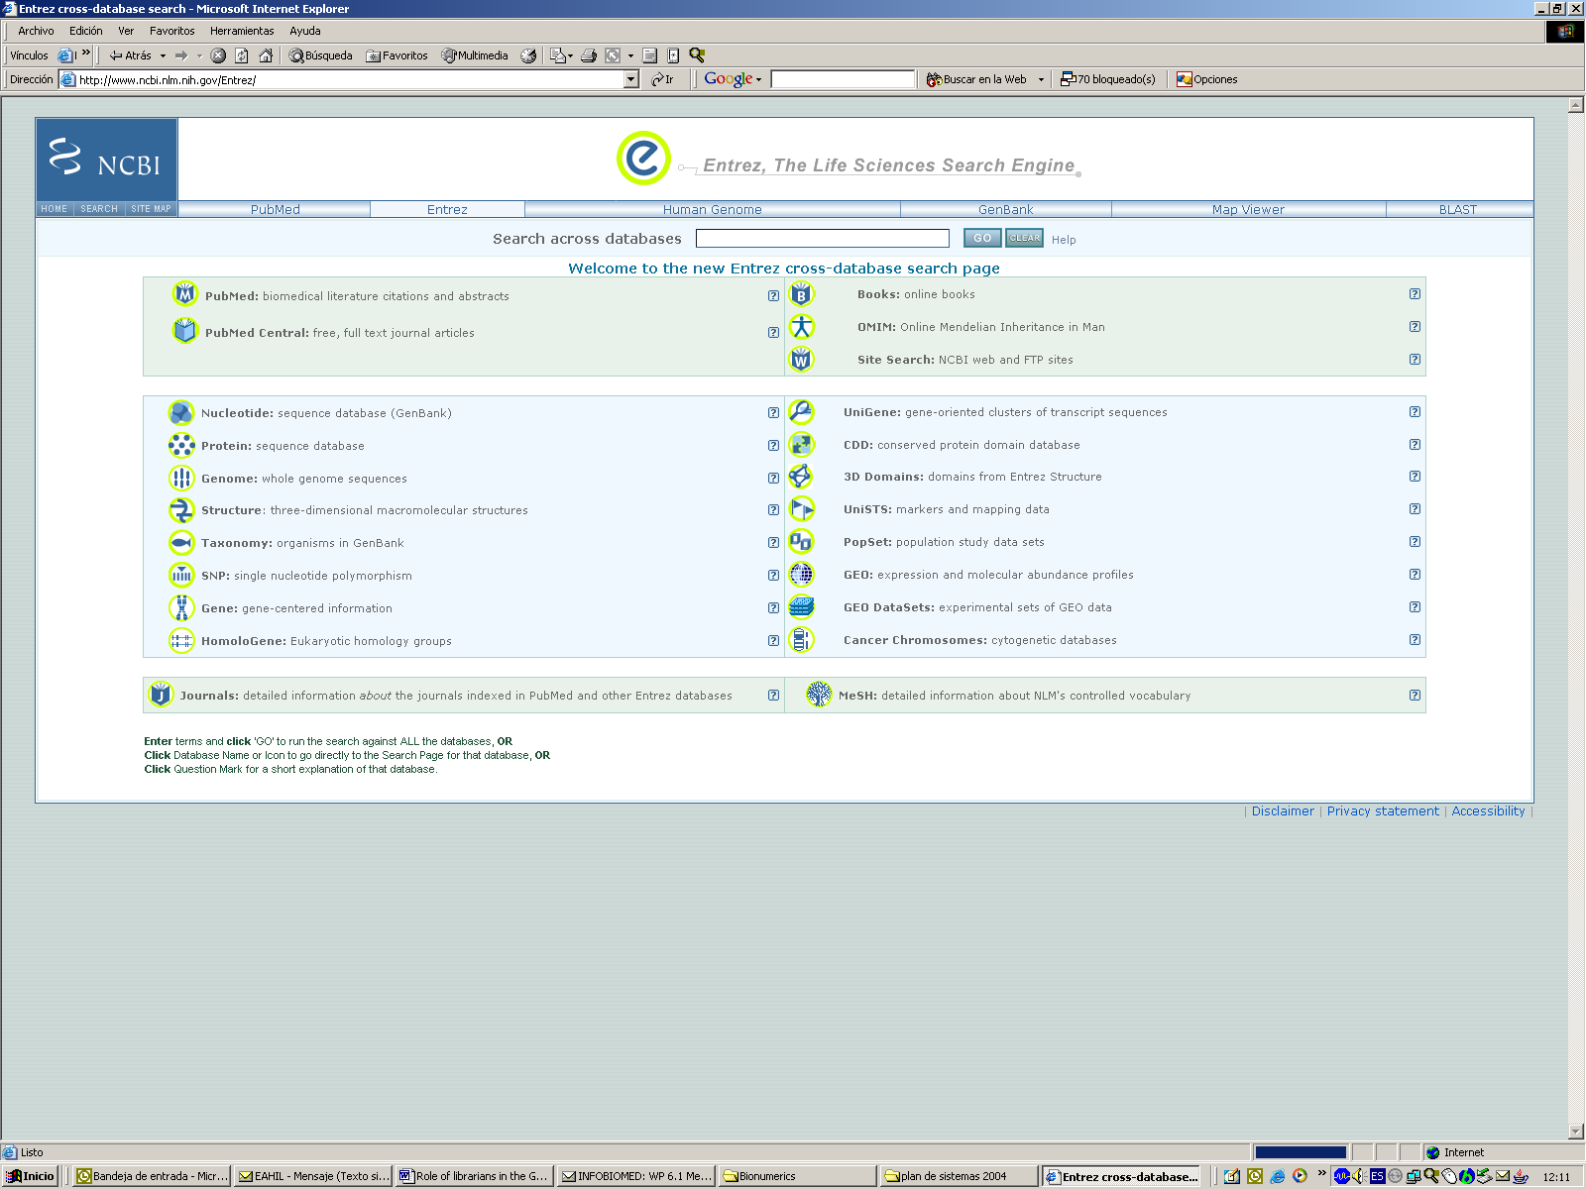

Figure 3. Entrez Global Query database search
Entrez can be searched with a wide variety of text terms such as author name, journal name, gene or protein name, organism, unique identifier (e.g., accession number, sequence ID, PubMed ID, MEDLINE UID), and other terms, depending on the database being searched.

The search goals are to: (a) Identifying a representative, well-annotated mRNA sequence record; (b) Retrieve associated literature and protein records; (c) Identify conserved domains within the protein; (d) Identify similar protein; (e) identify known mutations within the gene or protein; (f) identify structures with homologous sequence; (g) view genomic context and sequence region (13).

Example: Retrieve records in GenBank for “Plasmodium falciparum”
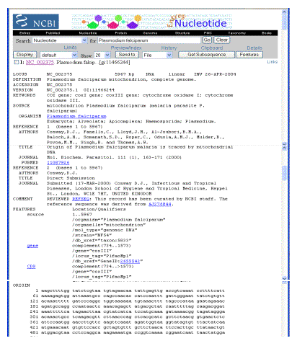

Sequence Retrieval System (SRS)

The main ways to access EMBL-Bank are through a query tool called the Sequence Retrieval System (SRS), which is available from the EBI at the EBI SRS server (http://srs.ebi.ac.uk) it is a free central resource for molecular biology data as well as a reference server for the latest developments in data integration, or by downloading data from the EBI's FTP server (14).
The SRS server at the EBI integrates and links a comprehensive collection of specialised databanks along with the main nucleotide and protein databases. The SRS system allows the databases to be searched using, for example, sequence, annotations, keywords, author names. Complex, cross-database queries can also be executed and users should refer to the detailed instructions which are available online.
SRS has become an integration system for both data retrieval and sequence analysis applications. The EBI SRS server is a primary gateway to major databases in the field of molecular biology produced and supported at EBI as well as a European public access point to the MEDLINE database provided by US National Library of Medicine (NLM). It is a reference server for latest developments in data and application integration. The new additions include: concept of virtual databases, integration of XML databases like the Integrated Resource of Protein Domains and Functional Sites (InterPro), Gene Ontology (GO), MEDLINE, Metabolic pathways, etc., and user friendly data representation.
Availability: SRS6 is a licensed product of LION Bioscience AG freely available for academics.
In order to compare the records in EBI with NCBI, we use the same example: Plasmodium falciparum and mitochondrion genome complete.

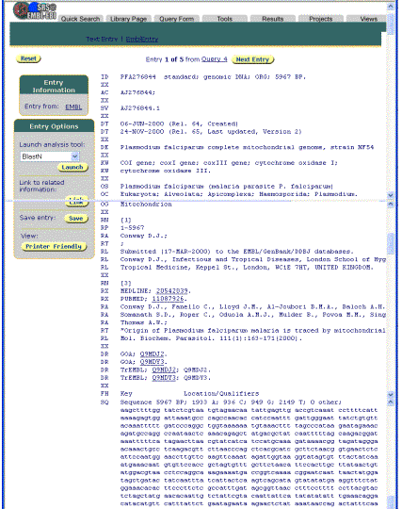

Genomic applications and the role of “Biolibrarians”

Some of the fields where the Genomic Science has practical applications in health are:

Vaccines

The advent of genomic sequencing is likely to have a greater impact on vaccines fields. Hepatitis B and C viruses are examples of pathogens that do not grow in vitro and cannot be approached through conventional vaccinology. The availability of their small genomes made it possible for researchers to identify genes coding for the viral envelope proteins and to develop recombinant vaccines that are used for the immunization or are at an initial stage of clinical testing of hepatitis C. Group B meningococcus is an example where several decades of conventional vaccine development had been unsuccessful.

The availability of the complete genome sequence of the Haemophilus influenzae in 1995 marked the beginning of a “genomic era” that opened the eyes of vaccine biologists to a new approach to vaccine design for the treatment of bacterial infections.

Furthermore, identification of genes through the powerful technology of genomics is likely to have a greater impact on Mendelian diseases and some complex diseases than on others.

Education

Health professionals must be knowledgeable about genomics to be able to use the outcomes of genomics research effectively. The public must also be knowledgeable about it in order to make informed decisions about participation in genomics research and to incorporate the findings of such research into their own health care. High-school students will be both the users of genomic information and the genomics researchers of the future.

Role of librarians in the Genomic Medicine era

The recent publication of the sequence of the Human Genome constitutes one of the events that had greater repercussion on society and on the progress of Science, in general and, of Biomedicine, in particular. The information generated by these studies and by those that are in progress now (individual genetic variability, new medications, gene-illness interactions) is voluminous, dispersed and complex in its structure

The 3 billion base pairs of the human genome are now available in public databases, homo sapiens is only one of many organisms whose genomes have been sequenced to date. This is accompanied by a flood of related information on genes, proteins, disease, and biomedical pathways. According to the journal Nucleic Acids Research, there are 548 online molecular biology databases as of January 2004.

Access to this information will constitute a habitual and routine practice of Health Sciences professionals. Therefore, this type of information could mean a new role for the “Biolibrarians” that work in Health Sciences Libraries. It would entail facilitating the access to all the resources related to the Human Genome and their applications in Medicine. In the British Medical Journal, April 2002, Bayat writes (16), “The clinical research teams that will be most successful in the coming decades will be those that can switch effortlessly between the laboratory bench, clinical practice, and the use of the sophisticated computational tools.
The librarians should have a basic understanding of the type of information contained in key genetic information resources and know how to search them. They must know how to answer basic questions such as locating resources, programs or databases, and technical questions as identifying appropriate tool for research or clinical needs.

Documentalists specialized in this area will acquire experience in handling the main resources and theinformation management techniques that take into account the special character of this information, since the most part it is available on the Internet. They will also know the links that allow integrating data and literature on genetics and disease.

REFERENCES

1 Burks, C. (1996) Molecular biology databases In Bishop,M.J. and Rawlings,C.J. (eds) DNA and Protein Sequence Analysis: A Practical Approach. IRL Press, Oxford, UK, pp. 1-30.

2 Norman, F. Genetic information resources: a new field for medical librarians.
Health Libr Rev. 1999 Mar;16(1):15-28.
3 Stoesser,G. et al. (2002) The EMBL Nucleotide Sequence Database. Nucleic Acids Res., 30, 21–26.
4 Brooksbank,C et al. The European Bioinformatics Institute's data resources. Nucleic Acids Research, 2003, Vol. 31, No. 1 43-50
5 Michael Y. Galperin . The Molecular Biology Database Collection: 2004 update
Nucl. Acids. Res. 2004 32: D3-D22.

6 Claude Discala, Xavier Benigni, Emmanuel Barillot, and Guy Vaysseix. DBcat: a catalog of 500 biological databases. Nucleic Acids Research, 2000, Vol. 28, No. 1 8-9

7 Burks C, Cassidy M, Cinkosky MJ, Cumella KE, Gilna P, Hayden JE, Keen GM, Kelley TA, Kelly M, Kristofferson D, et al. GenBank. Nucleic Acids Res. 1991 Apr 25;19 Suppl:2221-5.

8 Cathy H. Wu, Lai-Su L. Yeh, Hongzhan Huang, Leslie Arminski, Jorge Castro-Alvear, Yongxing Chen, Zhangzhi Hu, Panagiotis Kourtesis, Robert S. Ledley, Baris E. Suzek, C.R. Vinayaka, Jian Zhang, and Winona C. Barrer. The Protein Information Resource. Nucl. Acids. Res. 2003 31: 345-347

9 Amos Bairoch and Rolf Apweiler , The SWISS-PROT protein sequence database and its supplement TrEMBL in 2000. Nucl. Acids. Res. 2000 28: 45-48.

10 Imanishi, T. et al. Integrative Annotation of 21,037 Human Genes Validated by Full-Length cDNA Clones. PloS Biology (June 2004) vol.2 (6). e162 DOI: 10.1371/journal.pbio.0020162

11 Powledge, T. New resource emphasizes need for multiple genomic datasets to increase clarity |. The Scientist , April 20, 2004.

- Ostell, J. The Entrez Search and Retrieval System. The NCBI Handbook (2003).

- Geer R.C.; Sayers E.W. Tutorial section: Entrez: Making use of its power. Briefings in Bioinformatics, June 2003, vol. 4, no. 2, pp. 179-184.

- Zdobnov,E.M. et al. (2002) The EBI SRS server—new features. Bioinformatics, 18, 1149–1150.

15 Bayat, A. “Science, Medicine and the Future: Bioinformatics”. BMJ 324 (7344, 2002); 1018-22.

