The e-journals catalogue of Padua University: a proposal for a light solution to a heavy problem
Lucia Soranzo, Rosaria Candiloro, Lisetta Dainese, Tomaso Scarsi, Antonella Zane
Università degli studi di Padova | Centro di Ateneo per le Biblioteche

Introduction
Padova University, like other ancient universities, such as Bologna, Paris, Oxford and Cambridge, is one of the great cultural centres of the Western world, where the concept-construction of the Gymnasium Omnium Disciplinarum, all over the world, was first established and cultivated with features of completeness and continuity.
At Padova University, libraries are considered essential services supporting Learning and Research and are officially defined as "educational -scientific-cultural laboratories".
Padova University library system serves a population of about 60,000 students and 2300 of teaching staff.
The University Library System (SBA) is currently composed of 55 libraries; while 30 external libraries have joined following a participation agreement with the SBA. Since 1988, the automation of the library procedures and activities has been implemented with the result of an OPAC owned by the University Library System. This catalogue is part of the SBN’s on-line archive (National Library Service).

Although the holdings of paper format journals are visible on our OPAC, the electronic ones are not. Following the recent and rapid development of e-journals, the need emerged for their rational management and easy access: it became necessary to win the fragmentation and dissemination of this type of resources which were presented as separate lists published in the web pages of the university libraries often as rough lists.
As the current library automation system could not be used for the management of e-journals, it was decided to create a new catalogue totally devoted to them with the goal of having a single point of access for their retrieval and management.
A Working Group for the E-journal Catalogue was constituted in October 2001 with the purpose of creating a web accessible dynamic database. The choice of the group was towards a product that should prove light, flexible, and strongly user-oriented.
The aim was to develop a common user interface catalogue for e-journals that would: give visibility both to the titles subscribed centrally and by single libraries, promote communication to and from its users; handle malfunctioning; integrate the academic electronic resources (via direct links from databases to the catalogue); perform usage statistics; collect economic and administrative data.
The first release was produced in February 2002.

Technical Features
The catalogue search software has been entirely designed with open source programs. The database is made of 8 tables and the db server used is MySQL. The application server Zope has been used in order to search, insert, update and delete data. Usage statistics have been produced by Webalizer application and the in-house development CapereStats. The application runs on IBM x225, operative system Gentoo Linux. The server is located in Padova and hosts also Venice and Ancona Universities data. The update of the database is done by perl scripts from Excel files (when dealing with large amounts of records) or by web front-end from libraries.

A friendly user search interface with cross search options has been developed (FIG.1).

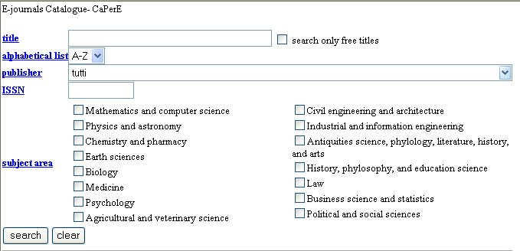

The fields that make up the user interface are: title ISSN, publisher, alphabetical list, subject areas.
Search may be made by alphabetical browsing, by publisher, by subject area, and search may be restricted to only free resources: although it must not be indicated the Boolean operator AND works in cross searching. Search modality is very simple: no truncation needs to be specified but it works at both ends of the terms on the basis of the stemming: all the user has to do is write some bits of the word(s) included in the title.
A staff interface is accessible to authorized librarians through password authentication (FIG.2) (FIG.3). Special features are designed for the system administrator.

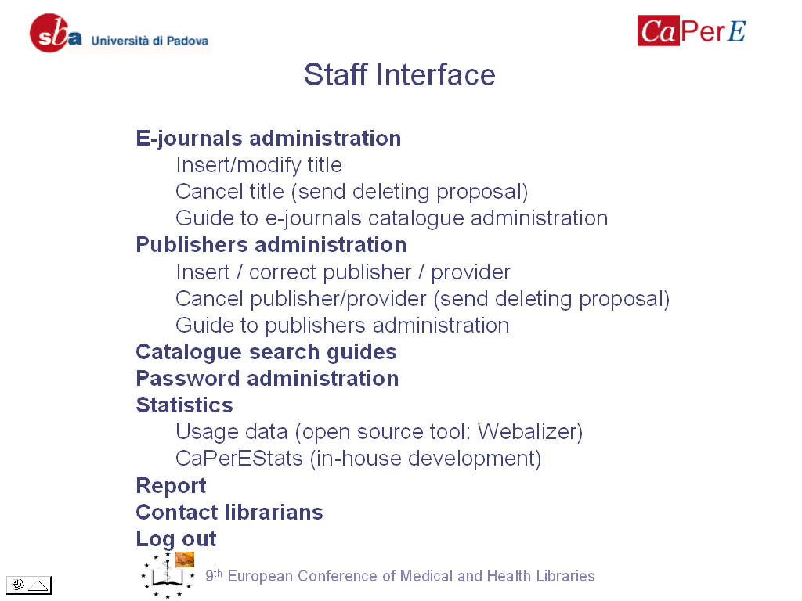
Figure 2. Staff interface
We chose to split the information about the titles into two tables: bibliographic data and holding information (Fig.3). This would allow to capture exclusively the basic data in the bibliographic record table and insert as many holding as necessary for each title. We decided that the cataloguing process should be kept at a very basic level.
To make information requests easy, each title leads to contact the librarian in charge of the subscription or the licence agreement.
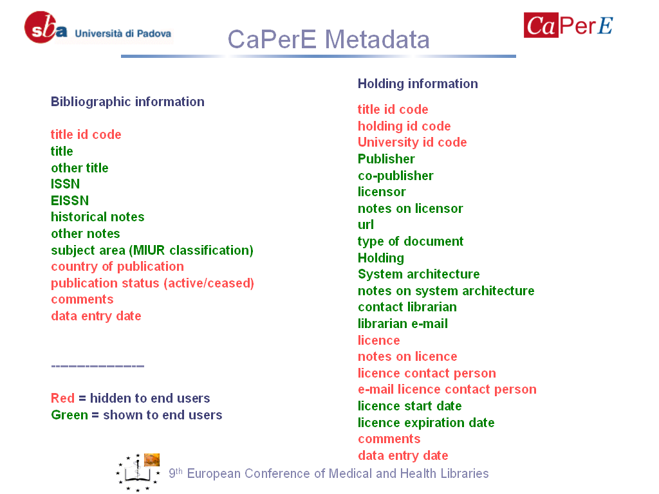
Figure 3. Capere metadata.
In 2003 the universities of Ancona and Venice signed an agreement with Padova University and became our partners in the choice of CaPerE for the management of their e-journals. All the partners have access to the same database and share the cataloguing process. Each library adds then its holding data. The customization is handled by the librarian administrator of each partner university

Achievements and current developments
The catalogue has proved to be easy to handle and flexible on the administration side, and user-friendly.
At present it consists of 8.800 e-journal titles grouped into subject areas, 3700 of which come from interuniversity consortium agreements for the purchase of e-journals (CIPE); 1900 are core collections; 3000 are directly handled by single libraries (through subscriptions or as free/open access journals).
We have succeeded in handling also free and open access journals.
Information about resources is given in an essential way in each title record, but there is a section in the main page that leads to detailed information about e-journals licence agreements.
Unique titles from different sources are merged thanks to the deduplication system developed on the basis of the ISSN, while the relevant information about holding leading to the sources are displayed separately.
The cataloguing process is easy and done cooperatively making the most of the participating librarians time.
The statistics developed in-house are proving a useful tool for collection policy as they take into consideration relevant parameters such as title, publisher, IP, local administrative data.
Communication from users and to users is made easy, each title is accompanied by the name and e-mail of the librarian in charge.
Current developments are focused on:
- introducing an English version of the user interface;
- join the IFLA/AIB iniziative @ your library / @lla tua biblioteca
- integration with SFX/Metalib (Ex Libris). We want to keep our catalogue in view of the friendliness of the system and the detail of information we can handle with it. Capere will become source to SFX and be searched by Metalib.

