The Role of US Academic Health Sciences Libraries in Planning and Implementing Integrated Advanced Information Management Systems (IAIMS)

Gary D. Byrd, Ph.D.
Director, Health Sciences Library
University at Buffalo
Buffalo, New York, USA

What is IAIMS? It is an acronym coined by the U.S. National Library of Medicine in the early 1980’s for a grant-funded planning process it has been supporting for over twenty years. For the first ten years of the program, IAIMS stood for Integrated Academic Information Management Systems, but in the mid-1990’s the meaning was changed to Integrated Advanced Information Management Systems to reflect the significant advances in information technology, including the World Wide Web, being used to manage health information in all health sciences centers.

The following are some of the key elements of a more formal definition for IAIMS. It was originally a pre-Web vision for the integrated management of knowledge-based and other health information in academic health sciences centers. It is fundamentally a conceptual approach to institution-wide information technology (IT) management. As such it includes both an integrated network infrastructure plus the organizational and systems structures needed to effectively management the institution’s knowledge resources. IAIMS is also an ongoing strategic planning process with the goal of providing all health professionals with convenient and comprehensive access to relevant and useful information in all formats.

Today we certainly recognize that information or knowledge management is a core mission of academic health sciences centers, along with the traditional missions of teaching, research and patient care. This includes stewardship over the life cycle of scholarly health sciences knowledge from its creation to its storage, manipulation, and dissemination as well as the effective use of all forms of relevant data, information and knowledge. Also, importantly, information and knowledge management, in the IAIMS context, includes an institution’s own knowledge stores as well as links to all relevant external knowledge.

The IAIMS vision started in 1980 with a Delphi study conducted by Nina Matheson, a distinguished academic health sciences librarian who took a leave from her career to conduct this study which was funded jointly by the Association of American Medical Colleges (AAMC) and the National Library of Medicine (NLM). The study analyzed data from all US academic health sciences libraries as well as from interviews with librarians and medical center leaders and site visits to many libraries. The final report from that study was published as a special supplement to the October 1982 issue of the Journal of Medical Education with the title: “Academic information in the academic health sciences center: roles for the library in information management.” The report’s co-author was Dr. John A.D. Cooper who was serving as president of the AAMC.

The Matheson-Cooper Report, as it was subsequently called, concluded that in 1982 US academic health sciences centers were “poorly positioned to respond to the new demands of an electronic information-based society” and went on to describe a number of key information management problems. These included: fragmented information systems; the lack of strategic planning for information technology; the lack of effective information management leadership; and the unrecognized leadership potential of librarians. The Report recommended the phased development of “integrated information management systems” with library leadership to work towards the establishment of:
- Interfaces to the world’s biomedical knowledge base
- Information and database management services
- Information transfer, brokering and research
- Interfaces for information access networks
- Expert knowledge bases
- Research to develop new information technologies, and
- Collaborative roles for library faculty throughout the medical center.

The figure below illustrates the Report’s information resources integration model:

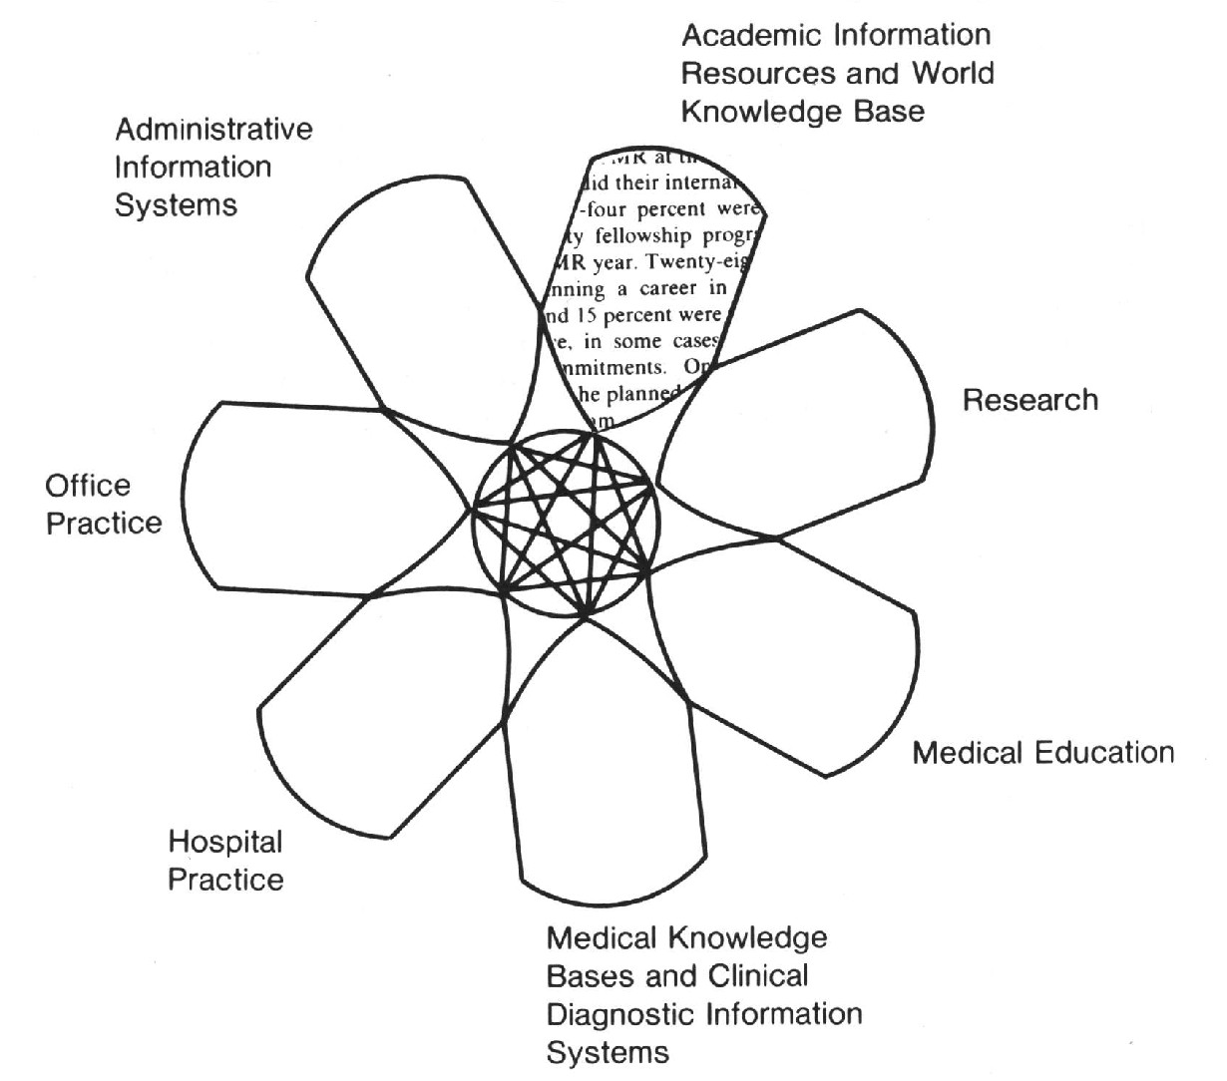

The Matheson-Cooper Report has had a continuing strong influence on information systems planning to the present. It has been cited over 400 times, in the library, medical education and informatics literature. It led directly to the creation of the NLM IAIMS grant program and helped to clarify our vision for what integration management really means. With the development of the World Wide Web, the IAIMS vision has helped academic health sciences leaders recognize that true integration reflects both syntax and semantic meaning, rather than just the superficial kinds of integration found on the Web with its simple hyperlinks connecting a huge volume of unfiltered, but visually attractive, Internet resources through high-speed world-wide networks.

The National Library of Medicine’s IAIMS grant program started in 1984 and continues to the present. The original program awarded grants in three phases: Phase I lasting 1-2 years for planning, Phase II also lasting 1-2 years for modeling prototype integrated systems (this phase was terminated in 1987), and Phase III lasting from 3 to 5 years for full-scale implementation and operations efforts throughout an organization. More recently, NLM has added three new IAIMS grant opportunities: small pilot project grants, testing and evaluation grants, and fellowship training grants for potential future leaders. All of these new grants can be funded for up to 2 years. Through 2004 some 66 IAIMS grants have been awarded; 44 for planning, 11 for model development, 12 for full-scale implementation and operations, 1 for a pilot project and 2 for testing and evaluation projects. These grants were awarded to 44 different organizations including 38 academic health sciences centers, 5 hospitals, 1 association (the American College of Obstetricians and Gynecologists) and 2 others (Virginia Tech University and the Fox Chase Cancer Center). The total dollar amount of these grants is now approaching $54 million.

The following are some of the academic health sciences centers that are currently recognized as national leaders in implementing the IAIMS vision:
- The University of Pittsburgh in Pennsylvania
- Vanderbilt University in Tennessee
- Columbia University in New York City
- The City of Hope National Medical Center in California
- The University of Washington in Seattle
- The University of Missouri in Columbia
- Yale University in Connecticut
- Duke University in North Carolina
- Georgetown University in Washington, DC, and
- Baylor University in Texas

Examples of the integrated information management systems and services that have been implemented with IAIMS grant support include:
- A clinical event monitoring system deployed at the University of Pittsburgh
- A university-wide Information Architect role established at Vanderbilt University
- The Medical Information Networked Databases (MIND) system with outcome measures at the University of Washington, and
- The creation of new computer classrooms with information management courses at Georgetown University.

The IAIMS journal literature continues to grow at the rate of about 25 new articles each year and about 25% of these have been published in the Bulletin, or more recently, the Journal of the Medical Library Association. The remainder, mostly in informatics and medical education journals, include authors in over 20 different countries. The IAIMS Consortium meets regularly in connection with the American Medical Informatics Association and maintains a Website with a rich array of IAIMS planning resources from the member organizations and reports from their completed IAIMS grant projects. The URL for the Consortium is www.iaimscons.org .

In 2001 the AAMC and NLM decided to fund a new report to update the Matheson-Cooper Report. This study was led by Valerie Florance, who left a position as director of an academic health sciences library in New York to conduct the study, and then took a position at the NLM, where she currently manages the IAIMS grants program. This study also used the Delphi approach and reviewed more recent statistical data along with interviews, site visits and the advice of a distinguished review panel. The final 2002 report is titled Next-Generation IAIMS: Binding Knowledge to Effective Action and is coauthored by Dr. Florance and Dr. Daniel Masys from the University of California at San Diego.

This most recent IAIMS report found that the integrated information management concerns of health organizations have evolved from infrastructure and organizational issues to the problem of how to bind knowledge to effective action. The Report notes that there are continuing barriers and problems to implementing the IAIMS vision. These include:
- Marking quality and authority in complex information spaces
- Distinguishing superficial integration from true integration, and
- Facilitating information flows across the patient care, research and education missions of academic health sciences centers

The Next Generation IAIMS report also noted areas of significant progress as a result of planning and implementation at those organizations committed to the IAIMS vision, including:
- The establishment of unique identifiers for individual patients
- More effective IT management structures
- A growing recognition of the strategic importance of effective information management
- Better patient data security systems
- A growing amount of exciting informatics research.

Finally, this 2002 Report also pointed to the factors that most often contributed to successful IAIMS planning and implement work: a supportive institutional culture, good technical expertise, adequate IT financing mechanisms, effective organization and management structures, the development of new programs and partnerships, and a commitment to IT standards.

As a result of this report’s recommendations the IAIMS grant program at the NLM has been given a new focus on supporting efforts to integrate information content and deliver it to be both usable and useful. The IAIMS grant program now has three areas of fundamental interest: delivering context-appropriate information, developing information management standards, and building digital libraries.

The concluding section of this paper will briefly describe the Western New York IAIMS Planning project that was supported with NLM grant funds from 1998 to 2001. This project was based at the University at Buffalo (UB), but involved all the academic health sciences schools and healthcare organizations in the Western New York region. The project leaders were Gary Byrd, director of the UB Health Sciences Library, Dr. Bruce Holm, Associate Dean for Research at the UB School of Medicine and Biomedical Sciences, and Francis Meyer, Chief Information Officer for the KALEIDA Health System which includes four major teaching hospitals affiliated with UB. This project had the goal of developing a plan for integrated, advanced health information for Western New York and our vision was “a seamless web of health information resources and services encompassing patient care, teaching, learning, research and consumer health.”

The master plan grew out of the deliberations and recommendations of six planning teams including librarians, faculty, clinicians, researchers, administrators and technicians from all the participating schools and organizations. The following is a brief outline of the major integrated information management components in our Master Plan:

- Patient care information resources
  - A community electronic medical record system
  - A shared pediatric immunizations system
  - A regional cancer care benchmarking system
  - A shared master drug formulary
- Research information resources
  - A center for informatics research and training
  - A research funding support system
- Educational information resources
  - A Web-based cultural competency course for health professionals
  - Shared curriculum management systems for the health sciences
- Knowledge-based information resources
  - Enriched electronic library resources
  - A portal to Western New York centers of health expertise
- Health administration information resources
  - A community health data warehouse
  - Regional health data security standards
  - A shared Internet video system for seminars and telemedicine
  - A regional physician credentialing system

- Network infrastructure information resources
  - Regional health information network standards
  - Regional health applications architecture standards

This regional IAIMS planning process faced a number of significant barriers which have so far prevented the full implementation of most of recommended components of our Master Plan. These included:
- The often overlapping and competing organizational governance structures for the participating schools and healthcare organizations in our region,
- The many changes in leadership and the organizational boundaries of the participating organizations during our planning process (for example most of the hospitals merged into two competing large healthcare systems), and
- The lack of a truly shared vision for integrated information management among the many different schools, hospitals, insurance companies, government agencies, and other community organizations.

Despite these barriers, however, the Western New York IAIMS planning process can now point to a number of significant successes, in which our region’s health sciences librarians have played leadership roles. These include:
- Two new shared clinical decision support systems that are available for use in all the affiliated teaching hospitals as well as the UB health sciences schools,
- A “Grants Central Station” Web toolbox to support grant writing in the University and affiliated teaching hospitals,
- Regional standards for secure electronic patient care payment transactions between the major hospitals and insurance companies,
- A new UB graduate training program in medical/health informatics, and
- A new planning initiative to establish a regional repository of electronic patient care records

For more information about IAIMS in the United States, the Websites of the following organizations are a good place to start:
- The US National Library of Medicine Extramural Program Office:
http://www.nlm.nih.gov/ep/Grants.html
- The Association of American Medical Colleges (for the Next Generation IAIMS study):
http://www.aamc.org/programs/betterhealth/start.htm
- The IAIMS Consortium:
http://www,iaimscons.org/

